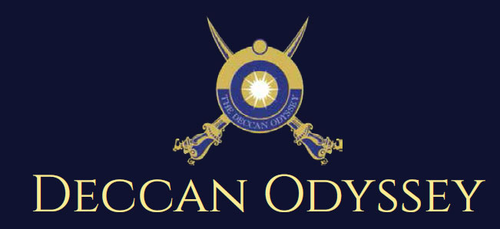

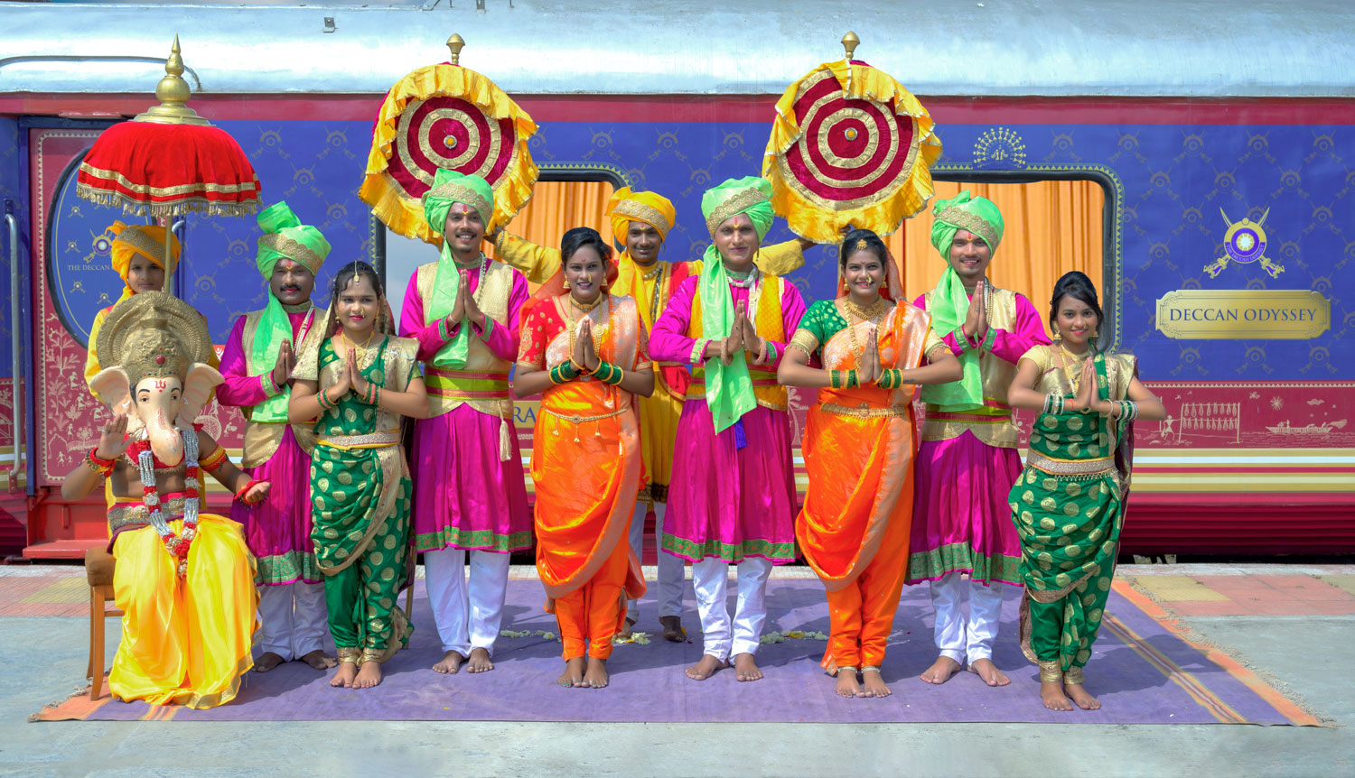

There's something unique about trains. They make you nostalgic. They transport us to far off places and we every day wake up to a new land of mystic and wonders. Trains are home to countless stories.

"Mickey Mouse popped out of my mind onto a drawing pad 20 years ago on a train ride from Manhattan to Hollywood at a time when business fortunes of my brother Roy and myself were at lowest ebb and disaster seemed right around the corner".

Walt Disney

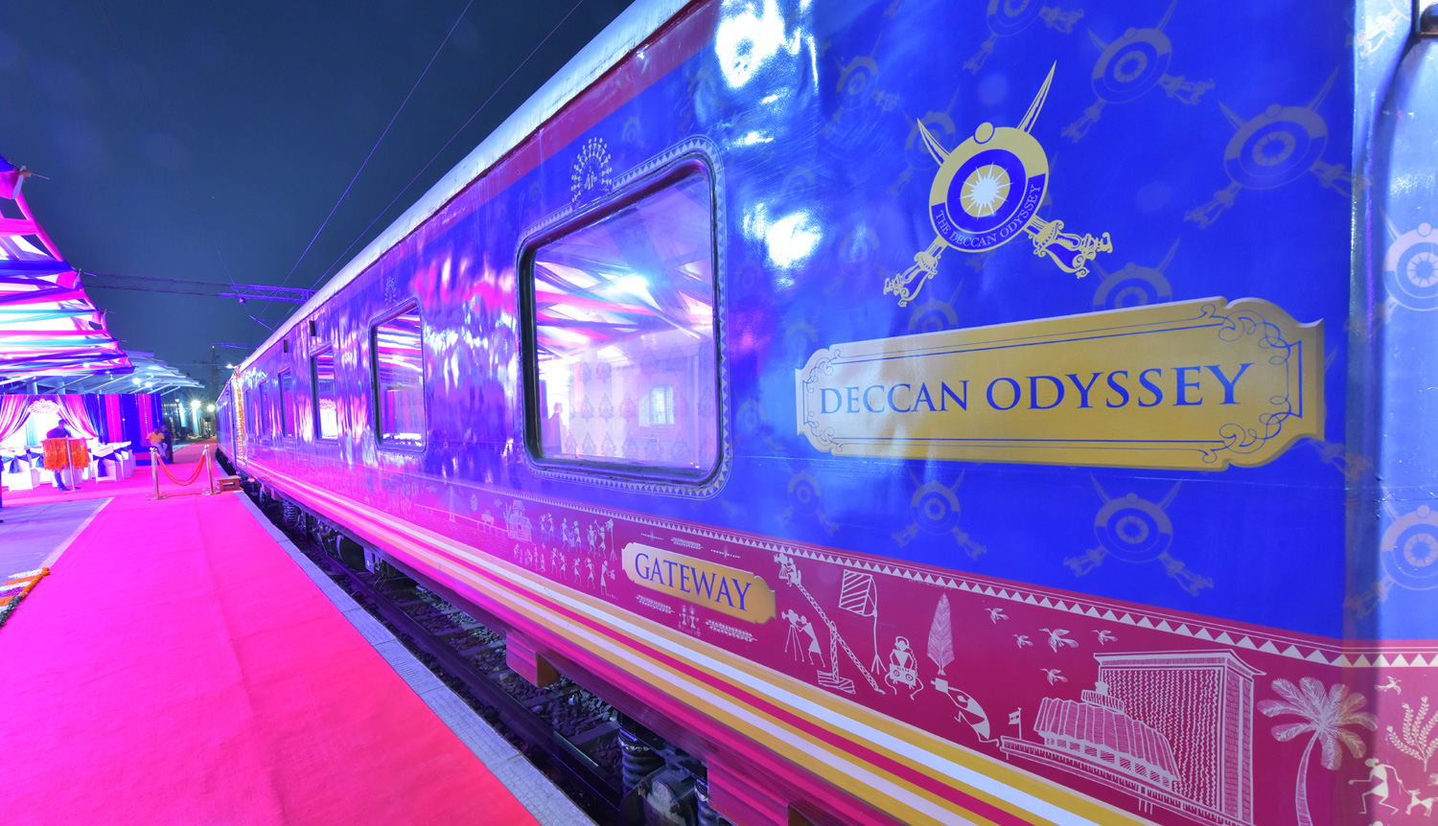

A journey that remains, magical and memorable. The Deccan Odyssey Train Routes and journeys designed to discover the art, architecture, culture, history and wildlife in style. Choose from set of excellent journeys that take you through different parts of India.

TRAIN LAYOUT
Passenger Cars (4 Coupes per Coach) (10)
Presidential Suite Cars (2 Coupes per Coach) (02)
Conference Car with Business Centre (01)
Restaurant Cars (02)
Staff, spare car (02)
Spa Car (01)
Bar Car (01)
Generator Cars with Luggage Store (02)
Total Coaches- 21 -
It can accommodate 88 guests at a time


PRESIDENTIAL SUITE

Dimensions  Cabin Area: 191 Sq Ft  Cabin Length: 8.4 meter  Cabin Width: 2.3 meter  Bed Length: 2.0 meter  Bed Width:0.9 meter  Cabin per Coach: 2 | Private attached bathroom with shower; channel music facility; Individual temperature control panel; direct dial telephone; electronic safe & small cupboard; Presidential suite cabins have a master bedroom with spacious living area, two bathrooms, Personal butler available in each sleeper carriage 24hrs.

DELUXE DOUBLE / TWIN CABINS
Dimensions  Cabin Area: 95 Sq Ft  Cabin Length: 3.97 meter  Cabin Width: 2.3 meter  Bed Length: 2.0 meter  Bed Width:0.9 meter  Cabin per Coach: 4 | Deluxe Coach features 4 Double/ Twin bed cabins. Direct dial phone, electronic safe, and individual climate control facility. Bathrooms come fitted with wash basin & shower, shower cubicle and running hot and cold water; Twin bed is 6' x 3'. Specially equipped cabin, for the comfort of our diﬀerently-abled guests.

RESTAURANTS

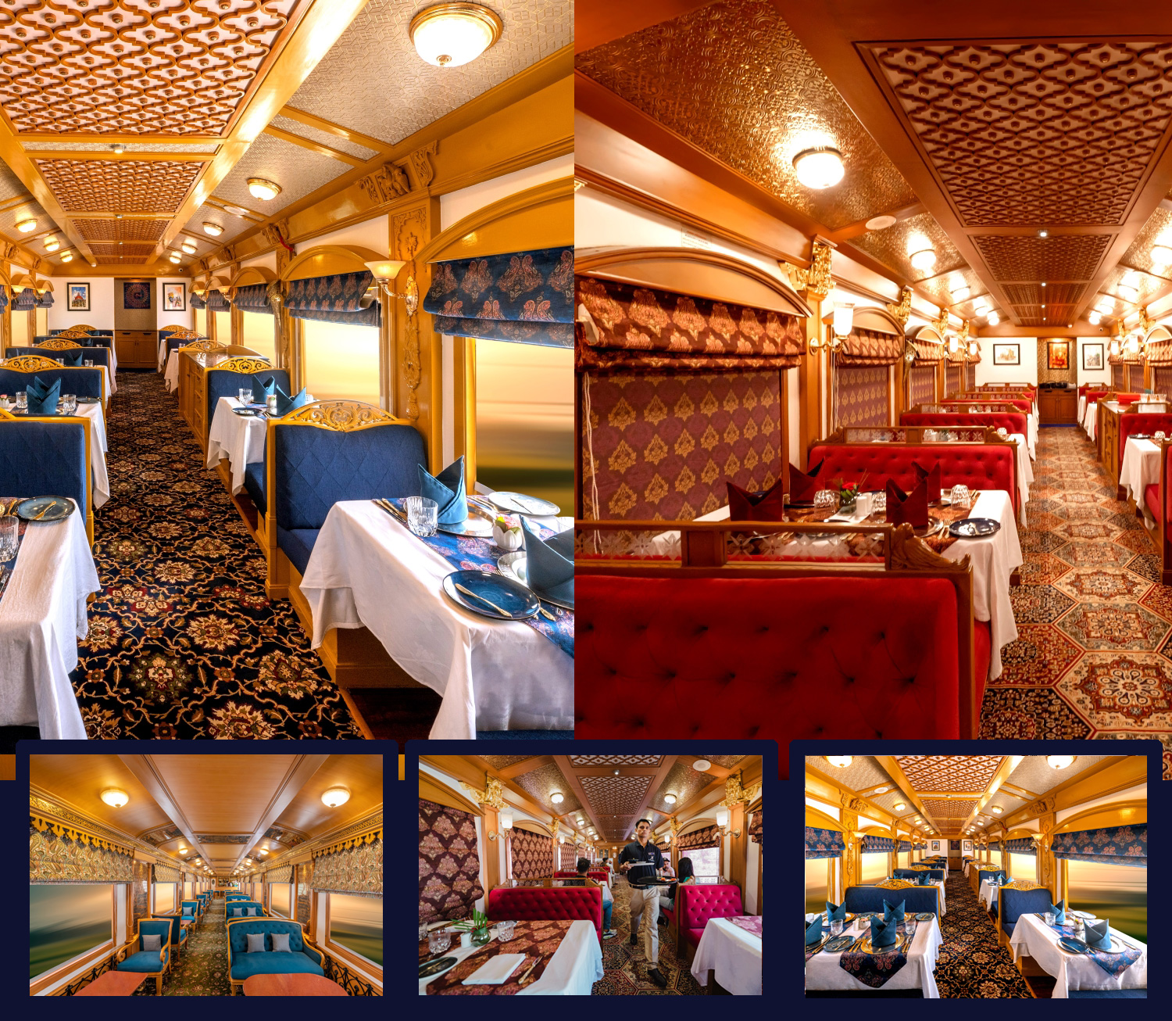
The Deccan Odyssey's two gourmet restaurants, Waavar and Utsav have been designed to keep the element of Indian royalty intact. Our chefs ensure the cuisine keeps pace with the train's journey, by creating local specialties of the every state that the train travels through. So you discover every location with all your senses, including your taste buds! Each meal also includes an International menu to choose from. To further enhance the gourmet experience, Deccan Odyssey presents travelers with a well-stocked bar - Gateway. This is the ideal spot to meet and know your fellow travelers, over an evening drink & snacks.

GATEWAY BAR
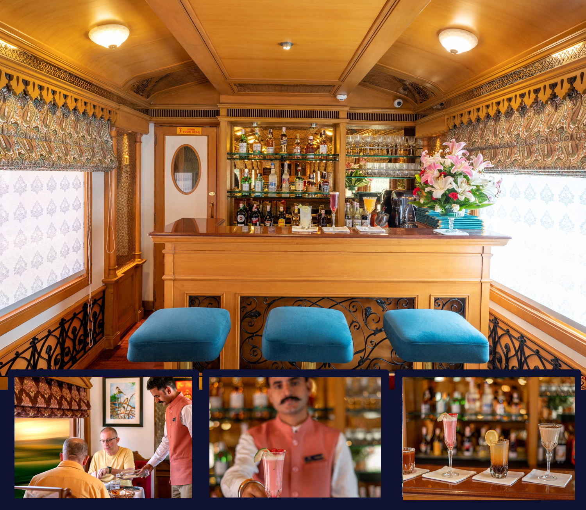
A Well-Stocked Bar with TV Facility serves Wine, Liquor and Spirits of Indian and International make.

CONFERENCE CAR
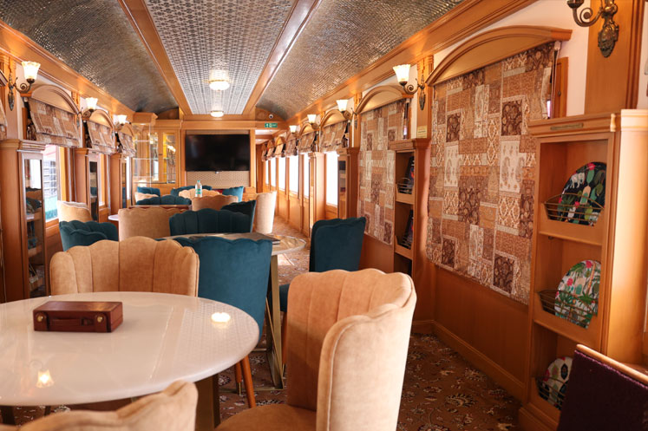
If work requires your time and attention, then our conference car, "Pankh" will take care of all your business needs. Equipped with the latest facilities, it ensures you manage your work efficiently even while you're away travelling.

SPA CAR

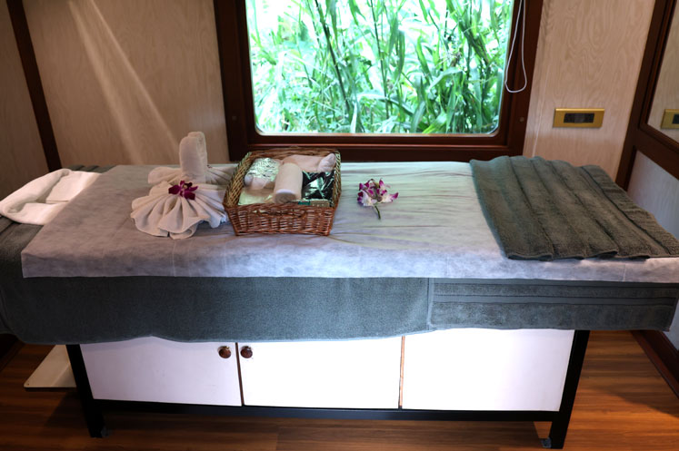

After a long day of exploration, head to Deccan Odyssey's wonderful spa "Ayush". The salon's well-trained masseurs, incorporate ancient Indian techniques to help you relax your body and rejuvenate your mind.

MAHARASHTRA SPLENDOUR ITINERARY

Destinations Covered:

Mumbai | Nashik | Aurangabad | Kolhapur | Goa | Sindhudurg | Mumbai

Duration:
07 Nights / 08 Days

MAHARASHTRA SPLENDOUR
Day 1 (Saturday): MUMBAI
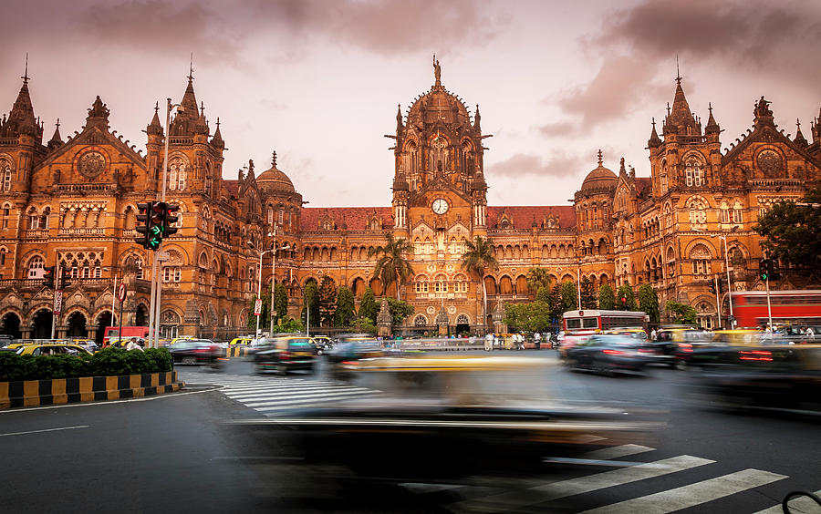
Board the Deccan Odyssey at Delhi – on to Nashik

Welcome aboard the Deccan Odyssey.

Early this evening assembles at the Chhatrapati Shivaji Terminus at approximately 1530 hours to complete the registration process and check in formalities for your Maharashtra Splendour journey, as you receive a traditional Indian welcome and enjoy a refreshing welcome drink.

After completion of all formalities, you will be shown to your delightful cabins. As you settle in, the Deccan Odyssey shall depart Mumbai for Nashik.

Dinner on Board

Overnight on Deccan Odyssey
(ETD at 1930 Hrs)
(ETD at 1715 Hrs)

Day 2 (Sunday): NASHIK
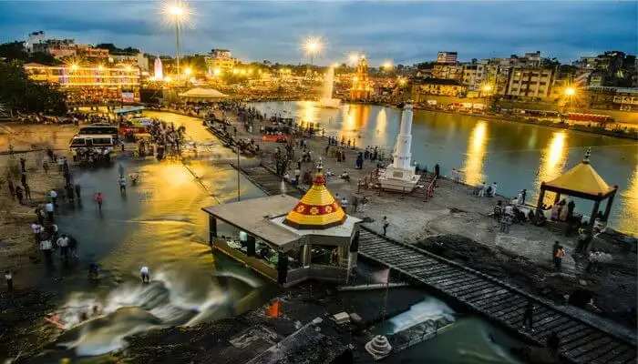
This morning the Deccan Odyssey brings you to the holy city of Nashik, which is rapidly gaining the status of being the wine capital of the country.
0900 Hrs: Disembark and spend the morning walking along the Godavari Ghats. Continue on through the lively market by the Ghats which sells everything from vegetables to lentils, dried
seafood to cow dung cakes and many things in between.
1200 Hrs: Leave for Sula vineyards for an exclusive tour of one of the finest Indian wine producing facilities.
1245 Hrs: Walk through vines laden with Chenin, Chardonnay and Shiraz grapes. Be taken through the age old ‘méthode traditionnelle’ used to make one of the best known brands of sparkling wines in India.

1400 Hrs: Lunch at Sula Vineyards

After a sumptuous lunch, return to the Deccan Odyssey and set forth for Aurangabad

Breakfast on board | Lunch at the vineyard | Dinner on board

Overnight on Deccan Odyssey

(Departure at 18:30)

Day 3 (Monday): ELLORA CAVES
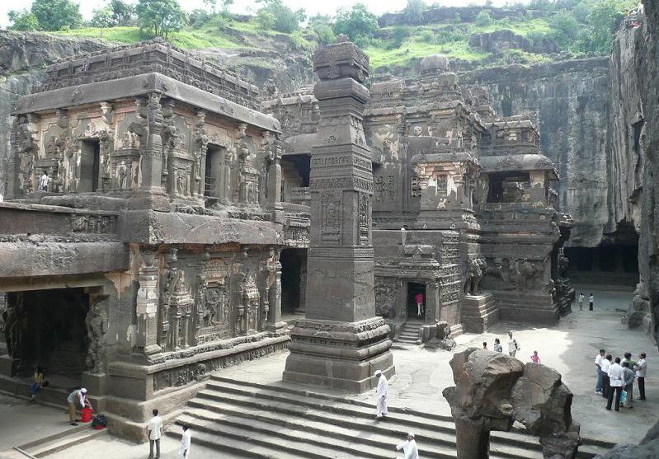
Aurangabad – Ellora Caves. As you enjoy breakfast, the Deccan Odyssey arrives at Aurangabad, from where a scenic drive takes you to the Ellora Caves
0830 Hrs : Disembark Deccan Odyssey for Ellora Caves.
0930 Hrs: Tour of Ellora Caves, carved into the side of a basaltic hill 30 km from the city. The finest specimen of cave-temple architecture in India, the site encompasses 34 rock-cut shrines representing Buddhist, Jain and Hindu art dating from the 4th to 5th century AD.
1230 Hrs: Reach station and board Deccan Odyssey
1300 Hrs: Lunch Onboard
In the evening, sit back, unwind and enjoy cocktails fixed by our bartender onboard, followed by a sumptuous dinner and a well deserved rest as the Deccan Odyssey proceeds towards Jalgaon to visit the exquisite Ajanta Caves.
Breakfast, Lunch & Dinner on board
Overnight on Deccan Odyssey

(Departure at 14:30)

Day 4 (Tuesday): AJANTA CAVES
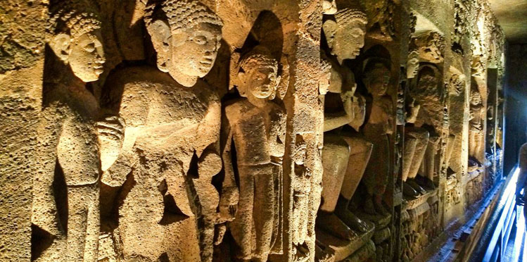
The Deccan Odyssey arrives at Pachora railway station this morning from where, after breakfast on board, you will disembark and drive to the Ajanta Caves, another World Heritage site and an architectural marvel of its time.
0800 Hrs: Disembark Deccan Odyssey for Ajanta Caves.
1000 Hrs: Visit of Ajanta Caves another World Heritage site and an architectural marvel of its time. The 30 rock-hewn Buddhist caves at Ajanta have been masterfully carved and are adorned with sculptures and paintings of Buddhist religious art, depicting universal pictorial art and are known to depict the fusion between Buddhist and Hindu faith.
1400 Hrs: Reach Railway station and Board Deccan Odyssey
Lunch will be on board the Deccan Odyssey as it continues on to the multifaceted city of Kolhapur.
The rest of the day is at leisure for you to relax and enjoy some of the activities available on board. Watch a movie, learn the rules of ‘carrom’, a popular Indian board game, from a Deccan Odyssey team member or book yourself a relaxing massage in our spa on board.
In the evening watch the tapestry of rural India unfold as you sip a sun downer before dinner.
Breakfast, Lunch & Dinner on board.
Overnight on Deccan Odyssey
(Departure at 14:30)

Day 5 (WEDNESDAY): KOLHAPUR
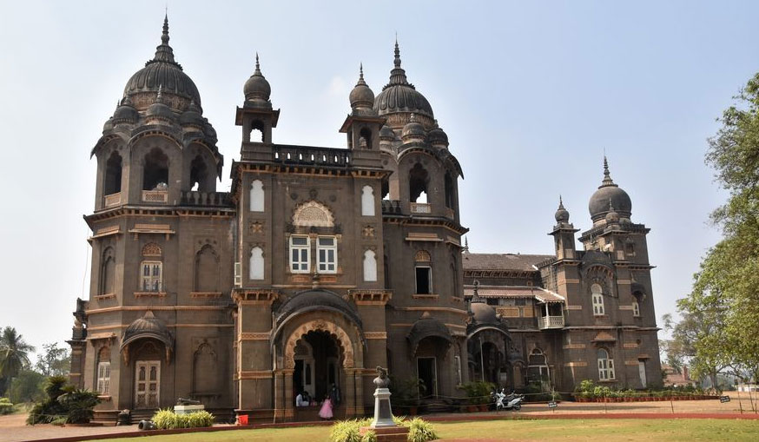
Watch the hinterlands of Maharashtra sweep past as you relish breakfast. Enjoy time at leisure as the Deccan Odyssey rolls into Kolhapur, a city of many hidden treasures, all waiting to be discovered!

1245 Hrs: Disembark Deccan Odyssey for City Tour of Kolhapur. After an early lunch on board you will disembark for a tour of the city.
1300 Hrs: Visit the New Palace Museum, a lovely basalt and sandstone octagonal Palace from the 19th century.
1400 Hrs: Explore the local markets for a pair of beautifully handcrafted Kolhapuri chappals that you can carry back with you as a souvenir.
1545 Hrs: Proceed to a special venue for tea followed by Lavanya Sandhya, a vibrant folk performance.
1715 Hrs: You will then visit the 1300-year-old Mahalakshmi temple, also called Shakti Peth,
Also witness Mardanai Khel ( Martial Arts) performance
1850 Hrs: Reach Railway station and Board Deccan Odyssey

After your sojourn into Kolhapur, you return to the Deccan Odyssey for dinner as we depart for India’s most happening destination – Goa

Breakfast, Lunch & Dinner on board

Overnight on Deccan Odyssey

(Departure at 19:30)

Day 6 (Thursday): GOA
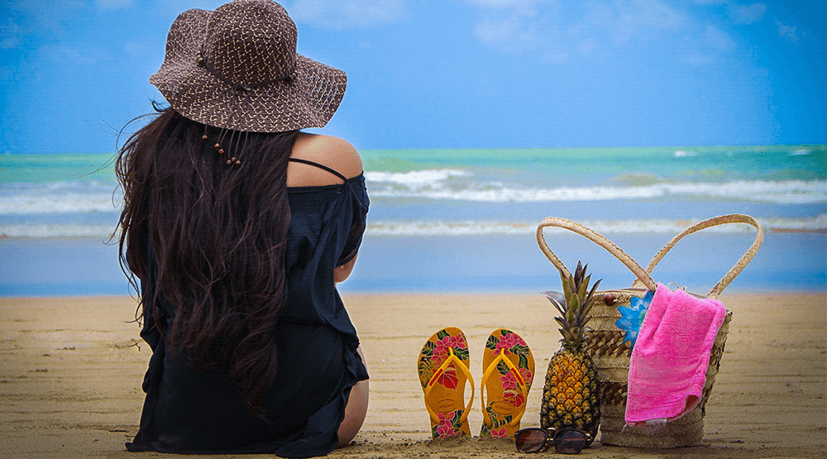
Today you arrive at Goa, India's smallest state, with strong Portuguese influences, having been a colony of Portugal till as late as 1961.
0830 Hrs: disembark and drive to Fontainhas, the Latin Quarters in Panjim which still has some well preserved houses built in Portuguese style architecture. Experience the UNESCO World Heritage Walk around Fontainhas with its winding alleyways adorned by tiled-roofed houses in spectacular shades of blue and red.
1215 Hrs: Lunch and Spice Plantation tour

1530 Hrs: Leisure time at the nearest Beach

1830 Hrs: Return to the Deccan Odyssey for dinner as it departs for Sindhudurg traversing through the Konkan, one of the most scenic railway routes in the country, bound by the Arabian Sea on the West and Sahyadri hills on the East, a marvelous
Breakfast on board |Lunch at the spice plantation | Dinner on board
Overnight on Deccan Odyssey
(Departure at 19:30)

Day 7 (FRIDAY): SAVANTWADI
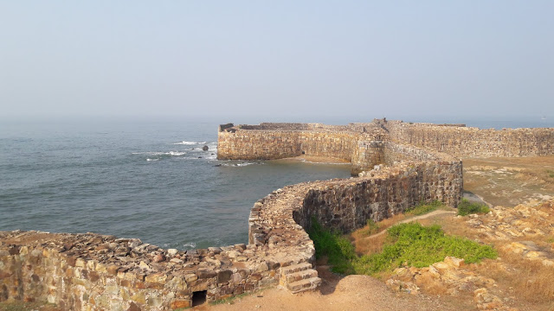
Arrive in Sawantwadi which lies on a rocky island just off the coast of Malvan.
0830 Hrs: Disembark Deccan Odyssey and drive to Pinguli
0915 Hrs: A visit to Sindhudurg’s Pinguli village and Sawantwadi Palace is on the cards today. Get a glimpse of the traditional Thakar folk arts and crafts at the local museum.
1200 Hrs: Visit to Sawantwadi Palace for a delicious lunch
1600 Hrs: Reach Railway station and board Deccan Odyssey..
Enjoy dinner on board as the Deccan Odyssey makes its way back to Mumbai
Breakfast & Dinner on board, Lunch at a Sawantwadi Palace.
Overnight on Deccan Odyssey
(Departure at 18:00)

Day 8 (Saturday): MUMBAI
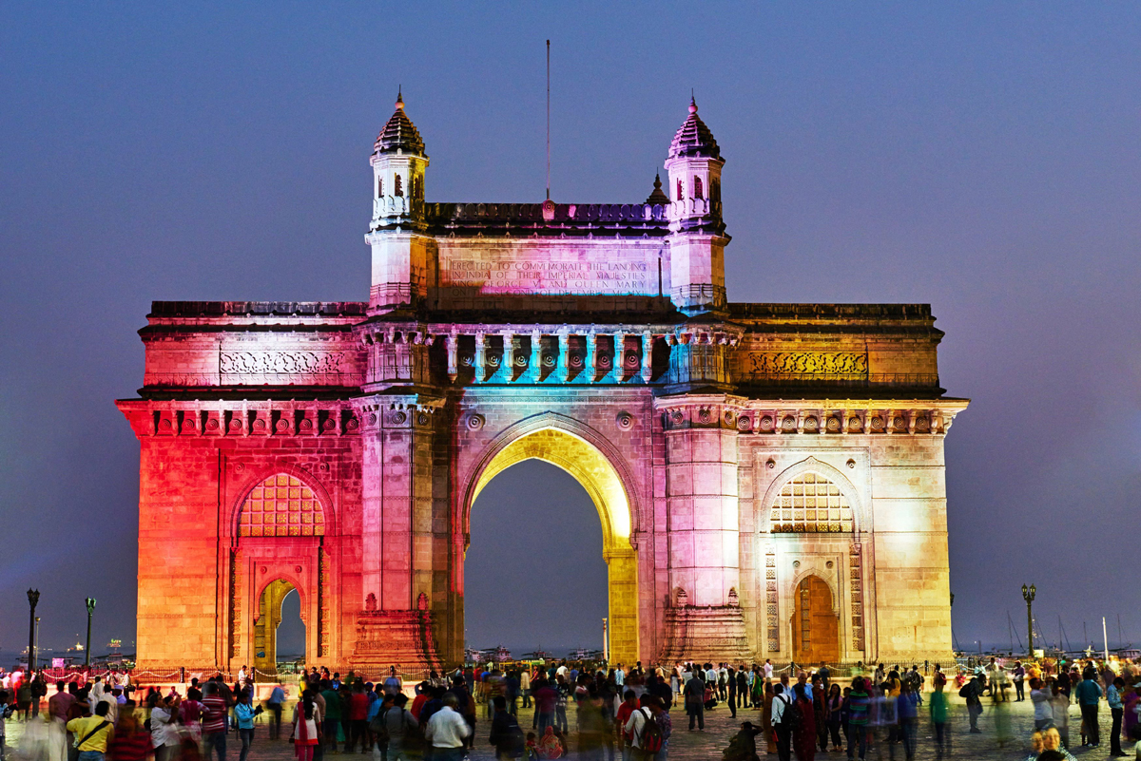
Disembark in Mumbai
Early this morning, after breakfast, you will disembark at Chhatrapati Shivaji Terminus Railway Station, Mumbai.
Bid farewell to the Deccan Odyssey as your royal passage through the grand vistas of India comes to an end.
Breakfast on board

DEPARTURE DATES
2025 | 2026 | 2027
NA | 26 September | 20 March

TARIFF 2025-2026 (Per Cabin Per Journey)
Category | Single Occupancy | Double Occupancy | 02 Children  (in a separate deluxe cabin)
Deluxe Cabin | $9,330 | $13,300 | Price on Request
Presidential Suite | $20,000 | $20,000 | Price on Request

TARIFF 2026-2027 (Per Cabin Per Journey)
Category | Single Occupancy | Double Occupancy | 02 Children  (in a separate deluxe cabin)
Deluxe Cabin | $9,330 | $13,300 | Price on Request
Presidential Suite | $20,000 | $20,000 | Price on Request

Inclusions | Exclusions
- Accommodation in double / twin bedded cabin with en suite bathrooms  - All meals (B, L, D)  - Soft beverages during the journey  - Valet service  - Still camera fees  - Guided oﬀ train excursions and game drives as illustrated in the itinerary – inclusive of entrance fees, park fees, transport and services of an English-speaking local guide | - Taxes including 5.00% (subject to change as per Govt. directives)  - Government Service tax, Insurance, gratuities  - Laundry and alcoholic Beverages  - Video and professional Still camera fees  - Arrival and Departure transfers  - International and Domestic air tickets  - Pre and Post tour accommodation and any tour extensions unless specifically mentioned as a part of the journey  - All activities mentioned as ‘options’ in the itinerary.
Booking Policy
20% of the tariff: at the time of the confirmation of the booking.
Remaining 80% of the tariff: to be paid 60 days prior to departure
Cancellation Policy
Retention of 10% of ticket value: cancelling 60 days prior to the departure date.
Retention of 20% of ticket value: cancelling 59 – 45 days prior to the departure date
Retention of 50% of ticket value: cancelling 44 – 30 days prior to the departure date
Retention of 100% of ticket value: cancelling 29 – 45 days prior to the departure date
Terms and Conditions
- All Costs are in USD
- The above costs are per cabin per Journey
- As the train runs on the tracks of the Indian Railways, the itineraries are subject to change in case of any changes in the routing
- Prices are subject to change in case of any amendment in the routing or other hikes such as fuel, taxes
- Children below 5 years of age shall be allowed free, subject to sharing of double bed with This is subject to availability of double bed at the time of booking
- Presidential Suite can accommodate up to 3 adults or 2 Adults and 2 children (One child up to 5 years of age and second child up to 12 years of age)
- Government Service tax of 5.00% (subject to change as per Govt. directives) is additional and will be charged extra on the published tariﬀ.
- All Departures and Arrivals are on Tentative basis and are subject to approval from Indian Railways.
- The Entire Deccan Odyssey Train is non-Smoking. For any particular requirement, kindly contact your Valet.
- We need minimum occupancy to operate all listed journeys, in event if we do not manage minimum occupancy we reserve the right to cancel the journey at least with 30 days prior intimation.
- As Train runs on tracks so you may experience sounds of passing trains and some shaking during the journey. This is a normal feature countrywide with trains in India.
- Paramedic on Board
