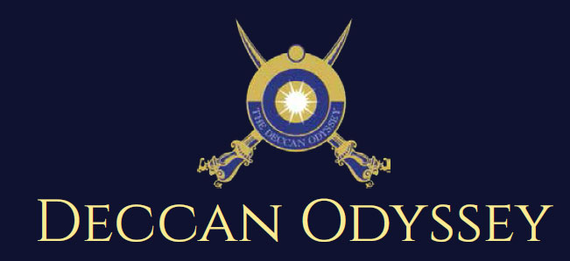

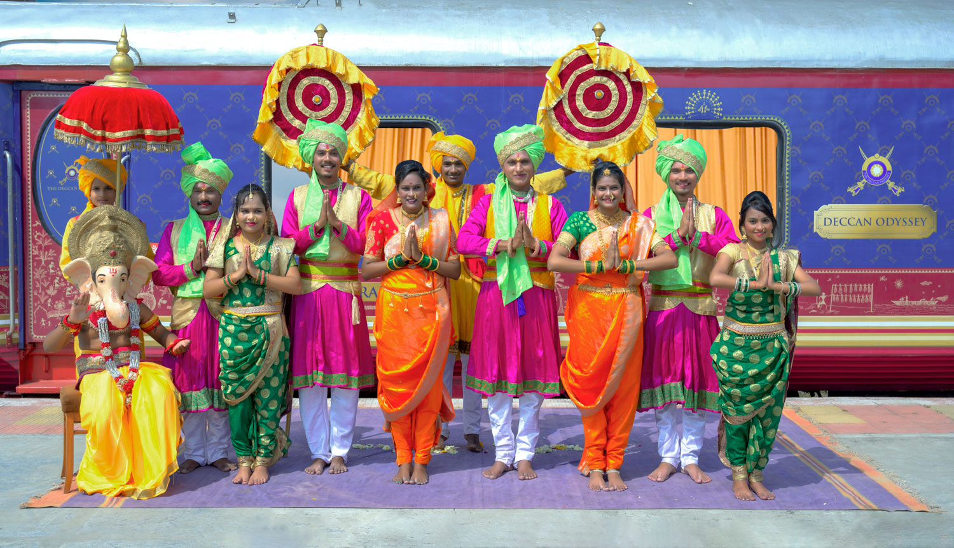

There's something unique about trains. They make you nostalgic. They transport us to far off places and we every day wake up to a new land of mystic and wonders. Trains are home to countless stories.

"Mickey Mouse popped out of my mind onto a drawing pad 20 years ago on a train ride from Manhattan to Hollywood at a time when business fortunes of my brother Roy and myself were at lowest ebb and disaster seemed right around the corner".

Walt Disney

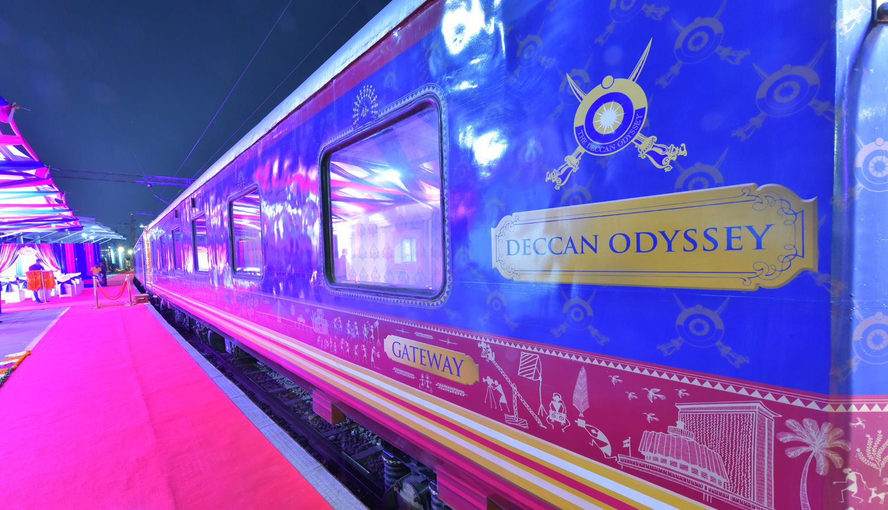

A journey that remains, magical and memorable. The Deccan Odyssey Train Routes and journeys designed to discover the art, architecture, culture, history and wildlife in style. Choose from set of excellent journeys that take you through different parts of India.

TRAIN LAYOUT
Passenger Cars (4 Coupes per Coach) (10)
Presidential Suite Cars (2 Coupes per Coach) (02)
Conference Car with Business Centre (01)
Restaurant Cars (02)
Staff, spare car (02)
Spa Car (01)
Bar Car (01)
Generator Cars with Luggage Store (02)
Total Coaches- 21 -
It can accommodate 88 guests at a time


PRESIDENTIAL SUITE

Dimensions  Cabin Area: 191 Sq Ft  Cabin Length: 8.4 meter  Cabin Width: 2.3 meter  Bed Length: 2.0 meter  Bed Width:0.9 meter  Cabin per Coach: 2 | Private attached bathroom with shower; channel music facility; Individual temperature control panel; direct dial telephone; electronic safe & small cupboard; Presidential suite cabins have a master bedroom with spacious living area, two bathrooms, Personal butler available in each sleeper carriage 24hrs.

DELUXE DOUBLE / TWIN CABINS
Dimensions  Cabin Area: 95 Sq Ft  Cabin Length: 3.97 meter  Cabin Width: 2.3 meter  Bed Length: 2.0 meter  Bed Width:0.9 meter  Cabin per Coach: 4 | Deluxe Coach features 4 Double/ Twin bed cabins. Direct dial phone, electronic safe, and individual climate control facility. Bathrooms come fitted with wash basin & shower, shower cubicle and running hot and cold water; Twin bed is 6' x 3'. Specially equipped cabin, for the comfort of our diﬀerently-abled guests.

RESTAURANTS

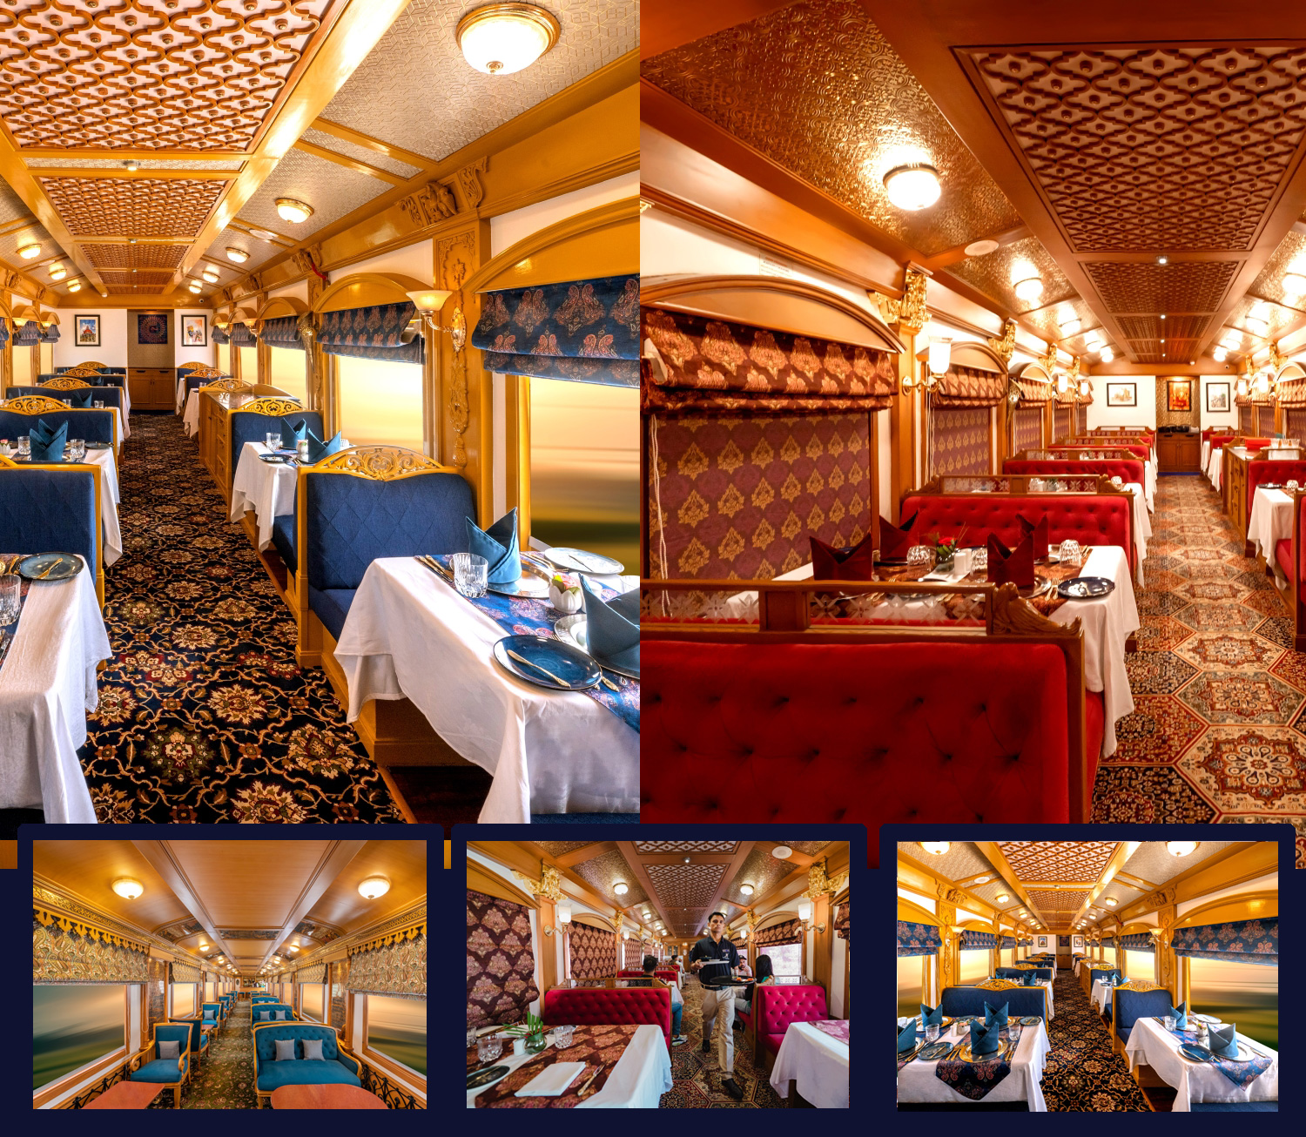
The Deccan Odyssey's two gourmet restaurants, Waavar and Utsav have been designed to keep the element of Indian royalty intact. Our chefs ensure the cuisine keeps pace with the train's journey, by creating local specialties of the every state that the train travels through. So you discover every location with all your senses, including your taste buds! Each meal also includes an International menu to choose from. To further enhance the gourmet experience, Deccan Odyssey presents travelers with a well-stocked bar - Gateway. This is the ideal spot to meet and know your fellow travelers, over an evening drink & snacks.

GATEWAY BAR
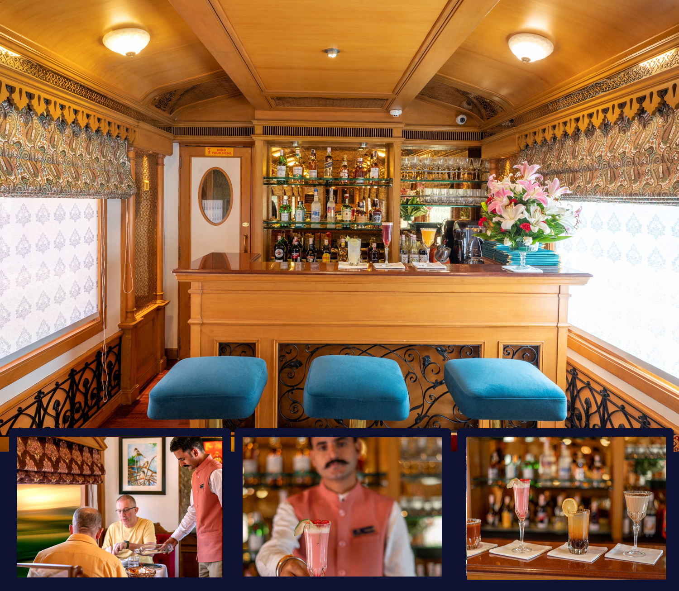
A Well-Stocked Bar with TV Facility serves Wine, Liquor and Spirits of Indian and International make.

CONFERENCE CAR
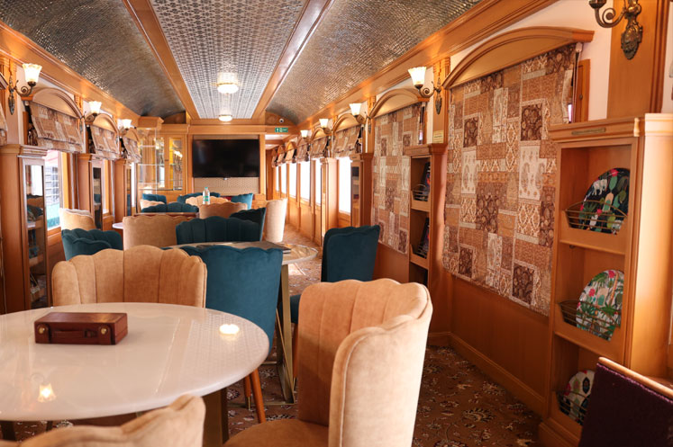
If work requires your time and attention, then our conference car, "Pankh" will take care of all your business needs. Equipped with the latest facilities, it ensures you manage your work efficiently even while you're away travelling.

SPA CAR

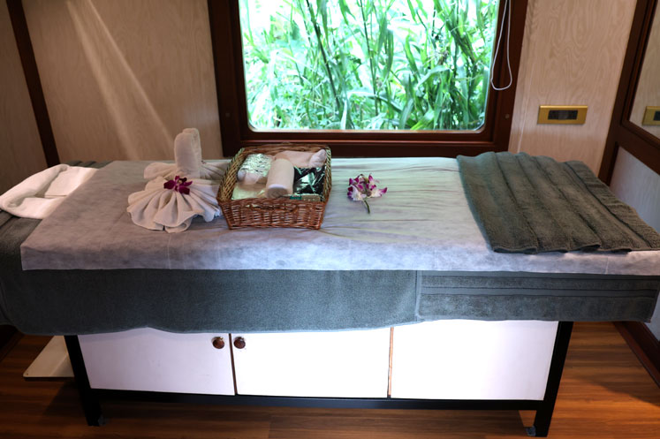

After a long day of exploration, head to Deccan Odyssey's wonderful spa "Ayush". The salon's well-trained masseurs, incorporate ancient Indian techniques to help you relax your body and rejuvenate your mind.

HERITAGE ODYSSEY ITINERARY

Destinations Covered:

Delhi | Agra | Sawai Madhopur | Udaipur | Jodhpur | Jaisalmer | Jaipur |Delhi

Duration:
07 Nights / 08 Days

HERITAGE ODYSSEY
Day 1 (Saturday): DELHI
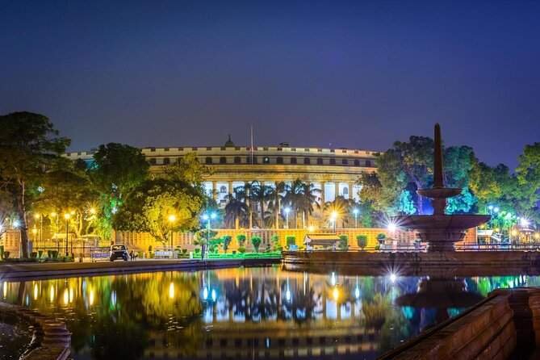
Board the Deccan Odyssey at Delhi – on to Agra

Welcome aboard the Deccan Odyssey.

This evening assembles at the railway station at approximately 1700 hours to complete the registration process and check in formalities for your Indian Odyssey journey, as you receive a traditional Indian welcome and enjoy a refreshing welcome drink.

After completion of all formalities, you will be shown to your delightful cabins. As you settle in, the Deccan Odyssey shall depart Delhi for Agra.

Dinner on board

Overnight on Deccan Odyssey
(ETD at 1930 Hrs)
(Departure at 1800 Hrs)

Day 2 (Sunday): AGRA
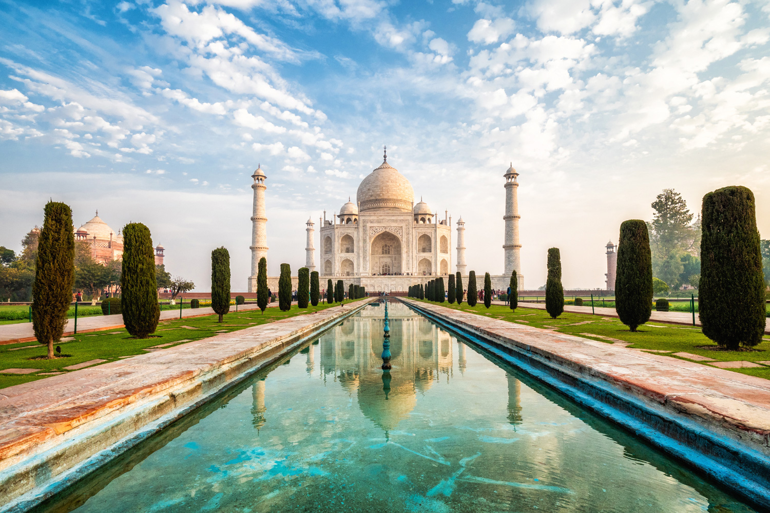
Arriving at Agra.

0830 Hrs: Deboard Deccan Odyssey and drive to Agra from Tundla Railway Station
0930 Hrs: You will visit the Taj Mahal, which was Emperor Shah Jahan’s gift of love to his beloved wife, Mumtaz Mahal, and is truly the world’s most wondrous monument.

1300 Hrs: Lunch at City Hotel.
1400 Hrs: Proceed for Agra Fort another outstanding example of Mughal architecture, and the seat of Mughal reign and administration for three generations. A visit to the Diwan-e-Am, ‘Hall of Public Audience’ and the Royal Pavilions is not to be missed.

1630 Hrs: Visit Kalakriti to witness the art of Inlay Work which can be found in Mughal structures. The Technique is known as Pietra Dura which have beautified Taj Mahal.
1900 Hrs: Return to the Deccan Odyssey for dinner and your onward journey to Sawai Madhopur.
Breakfast on board | Lunch at a City Hotel | Dinner on board
Overnight on Deccan Odyssey
(Departure at 20:00)

Day 3 (Monday): SAWAI MADHOPUR
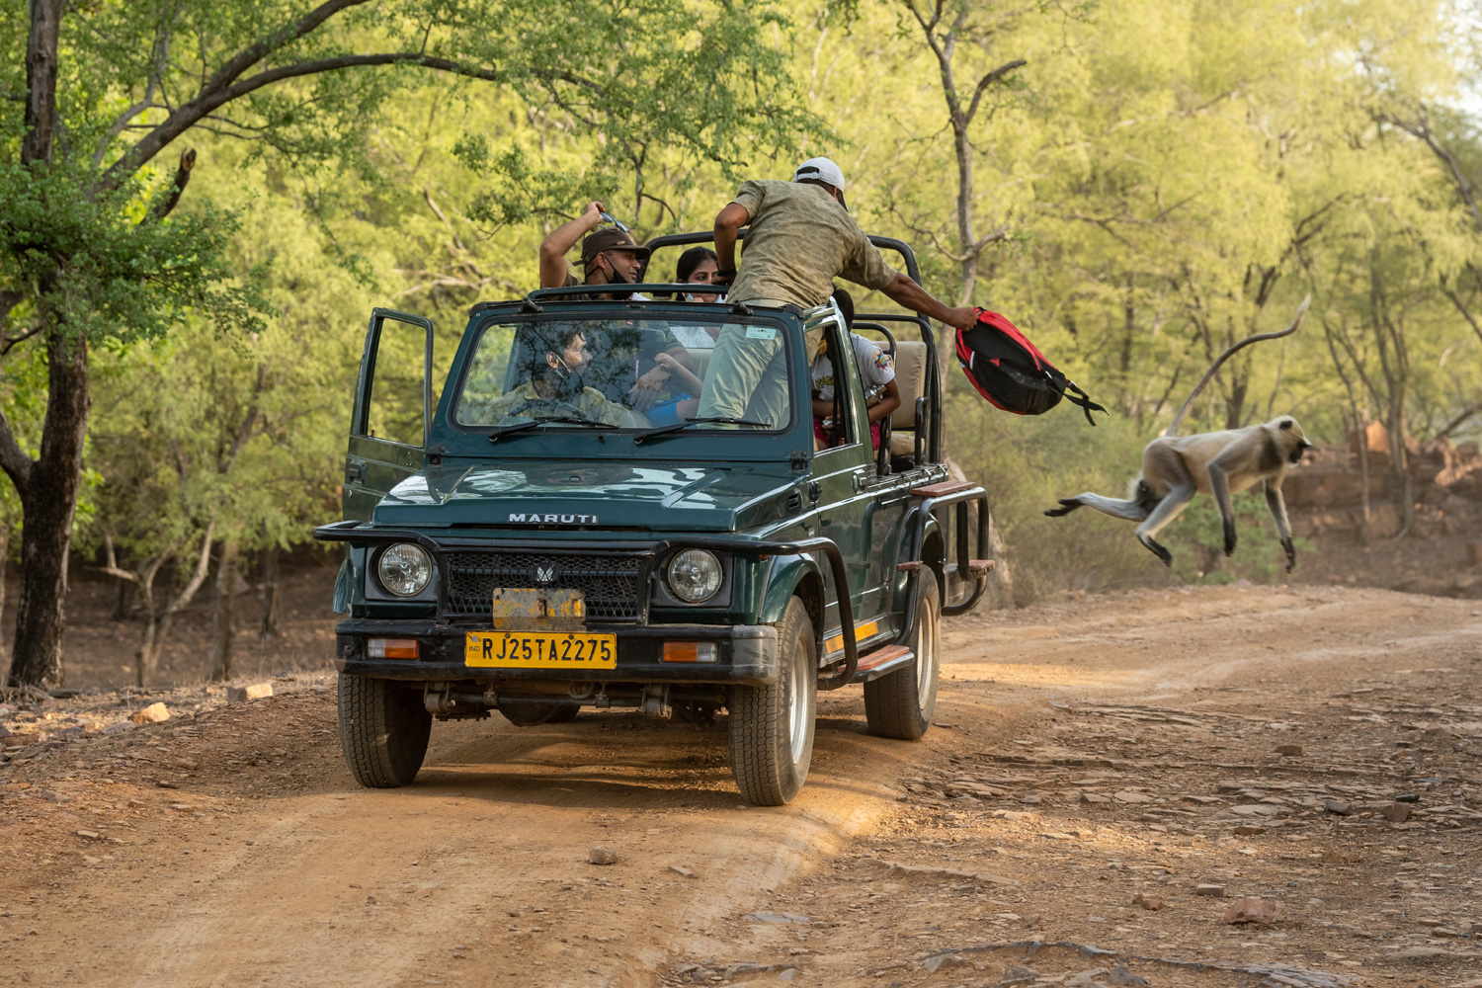
Sawai Madhopur, in Rajasthan is the alighting point for the famous Ranthambore National Park, and India’s efforts to conserve the dwindling tiger population can be seen here.

Enjoy Breakfast On Board Decan Odyssey.

0630 Hrs: Proceed for Ranthambore Morning Safari.

1130 Hrs: Return to Deccan Odyssey for Lunch as train departs for Udaipur.

(Departure at 11:30)

Day 4 (Tuesday): UDAIPUR
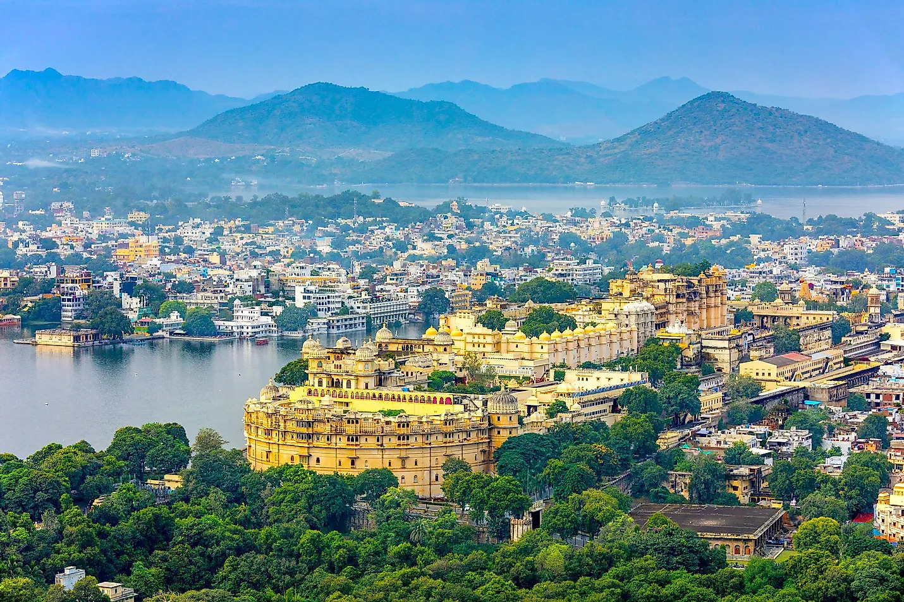
The Deccan Odyssey rolls into Udaipur in the morning. Enjoy your breakfast as you admire the picturesque landscape of the Aravali hills.

1000 Hrs: Disembark to visit the famous City Palace, the largest palace complex in Rajasthan, with its
scalloped arches, fretted balconies, and cupolas, which also houses the spectacular Crystal Gallery.
The tour of this magnificent city is completed with a boat cruise on the tranquil waters of Lake Pichola.

1330 Hrs: Lunch at City Hotel

1430 hrs : Proceed on a walking tour through the Old City of Udaipur and explore the Old City’s lively, busy and old-fashioned colourful bazar which still retains local charm and feel.
1800 hrs : Return to the Deccan Odyssey for a relaxed evening and dinner.
Breakfast on board | Lunch at a City Hotel | Dinner on board
Overnight on Deccan Odyssey
(Departure at 20:00)

Day 5 (WEDNESDAY): JODHPUR
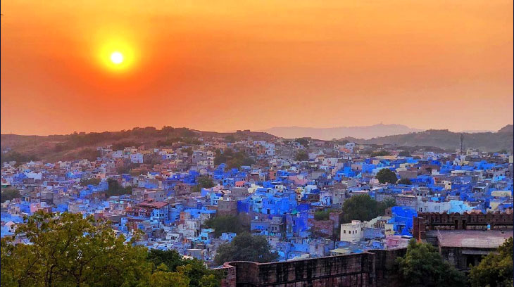
This morning as the Deccan Odyssey travels through the stronghold of the Marwar region.
Enjoy breakfast on board – Deccan Odyssey. Set out to explore the magnificent city of Jodhpur, also known as the Blue City, after the vivid blue-painted houses that surround the Mehrangarh Fort.
1000 Hrs: Deboard the train and proceed for sightseeing tour of Jodhpur
1030 Hrs: Mehrangarh Fort
1330 Hrs: Return to Deccan Odyssey for Lunch
1500 Hrs: Proceed to clock tower Experience glimpses of the lifestyle of the residents as you explore the city. Walk through the bustle of the Old Clock Tower market, past old havelis and house.
1830 Hrs: Return to Station
Having taken in your share of the sublime beauty of Jodhpur, return to the Deccan Odyssey and head for Jaisalmer.
Breakfast, Lunch & Dinner on Board
Overnight on Deccan Odyssey
(Departure at 20:00)

Day 6 (Thursday): JAISALMER
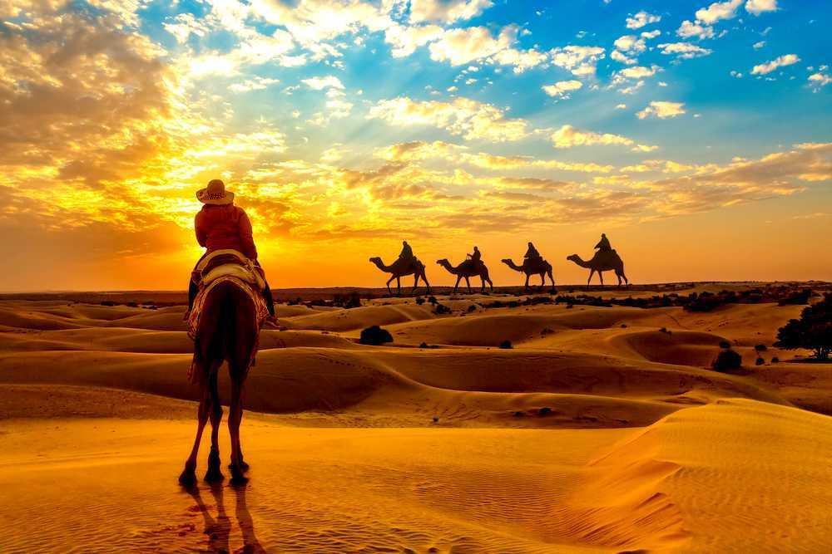
Arrive at Jaisalmer which is the heart of Thar Desert. Jaisalmer was founded by Rawal Jaisal in 1156 A.D. Explore the Jaisalmer city and the fort area.
0830 Hrs: Deboard the train and proceed for sightseeing tour of Jaisalmer

0930 Hrs: Visit Jaisalmer Fort & Nathmal Ki Haveli

1330 Hrs: Return to Deccan Odyssey for Lunch

1500 Hrs: Proceed for Dunes for Sundowners

1830 Hrs: Return to Deccan Odyssey

Breakfast, Lunch & Dinner on Board

Overnight on Deccan Odyssey

(Departure at 20:30)

Day 7 (FRIDAY): JAIPUR
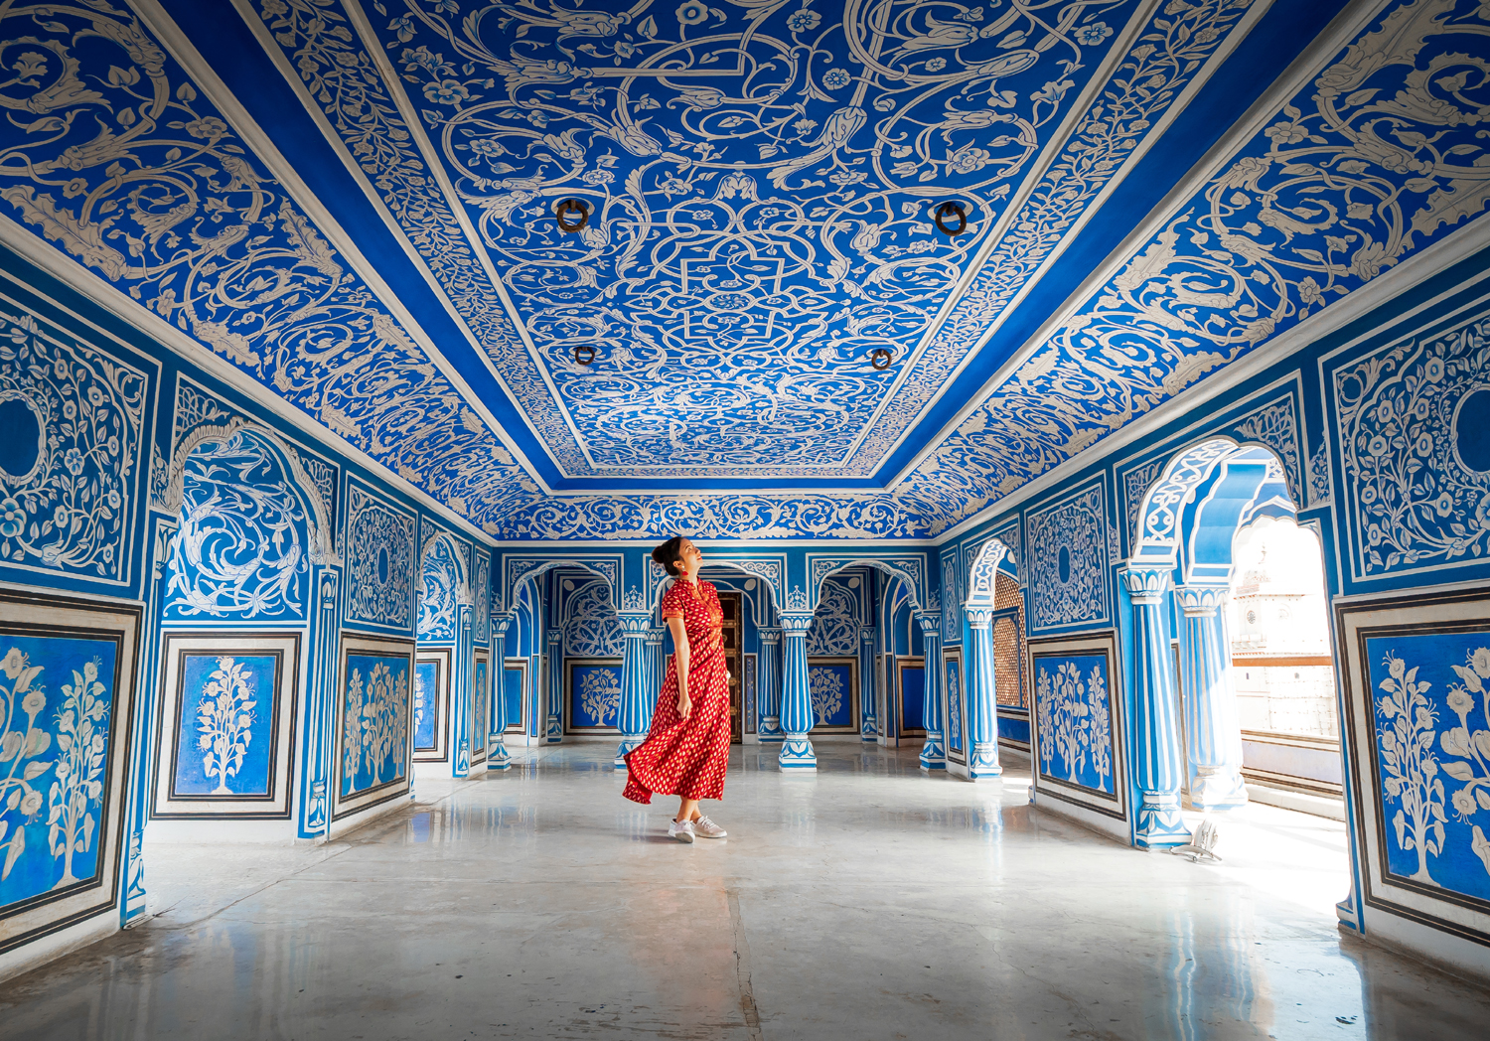
Legendary for the triumphs of its proud Rajputs, Jaipur, the City of Victory, is surrounded by the rugged Aravali hills - crowned by formidable forts - and beautiful palaces, mansions and gardens. Royal processions and parades, in all their splendour, graced these palaces and forts once.
0830 Hrs: Disembark from Station ( Welcome at the station)
0900 Hrs: Leave station for Amer Fort
1030 Hrs : Visit of Amer Fort
1300 Hrs: Lunch at City Hotel
1430 Hrs: Visit City Palace and drive past Hawa Mahal.
1900 Hrs: Return to Deccan Odyssey
Breakfast on board | Lunch at City Hotel | Dinner on board
Overnight on Deccan Odyssey
(Departure at 20:00)

Day 8 (Saturday): DELHI
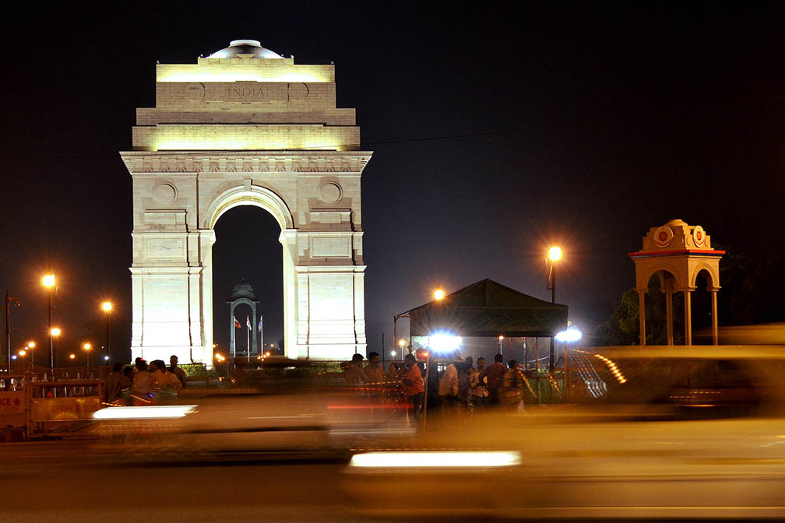
Disembark in Delhi

Early this morning, after breakfast, you will disembark at the Delhi Safdarjung Station.

Bid farewell to the Deccan Odyssey as your royal passage through the grand vistas of India comes to an end.

Breakfast on Board

DEPARTURE DATES
2025 | 2026 | 2027
22 November  20 December | 03 January  28 February  04 April  18 April  31 October  21 November  05 December | 02 January  27 February  17 April

TARIFF 2025-2026 (Per Cabin Per Journey)
Category | Single Occupancy | Double Occupancy | 02 Children  (in a separate deluxe cabin)
Deluxe Cabin | $9,330 | $13,300 | Price on Request
Presidential Suite | $20,000 | $20,000 | Price on Request

TARIFF 2026-2027 (Per Cabin Per Journey)
Category | Single Occupancy | Double Occupancy | 02 Children  (in a separate deluxe cabin)
Deluxe Cabin | $9,330 | $13,300 | Price on Request
Presidential Suite | $20,000 | $20,000 | Price on Request

Inclusions | Exclusions
- Accommodation in double / twin bedded cabin with en suite bathrooms  - All meals (B, L, D)  - Soft beverages during the journey  - Valet service  - Still camera fees  - Guided oﬀ train excursions and game drives as illustrated in the itinerary – inclusive of entrance fees, park fees, transport and services of an English-speaking local guide | - Taxes including 5.00% (subject to change as per Govt. directives)  - Government Service tax, Insurance, gratuities  - Laundry and alcoholic Beverages  - Video and professional Still camera fees  - Arrival and Departure transfers  - International and Domestic air tickets  - Pre and Post tour accommodation and any tour extensions unless specifically mentioned as a part of the journey  - All activities mentioned as ‘options’ in the itinerary.
Booking Policy
20% of the tariff: at the time of the confirmation of the booking.
Remaining 80% of the tariff: to be paid 60 days prior to departure
Cancellation Policy
Retention of 10% of ticket value: cancelling 60 days prior to the departure date.
Retention of 20% of ticket value: cancelling 59 – 45 days prior to the departure date
Retention of 50% of ticket value: cancelling 44 – 30 days prior to the departure date
Retention of 100% of ticket value: cancelling 29 – 45 days prior to the departure date
Terms and Conditions
- All Costs are in USD
- The above costs are per cabin per Journey
- As the train runs on the tracks of the Indian Railways, the itineraries are subject to change in case of any changes in the routing
- Prices are subject to change in case of any amendment in the routing or other hikes such as fuel, taxes
- Children below 5 years of age shall be allowed free, subject to sharing of double bed with This is subject to availability of double bed at the time of booking
- Presidential Suite can accommodate up to 3 adults or 2 Adults and 2 children (One child up to 5 years of age and second child up to 12 years of age)
- Government Service tax of 5.00% (subject to change as per Govt. directives) is additional and will be charged extra on the published tariﬀ.
- All Departures and Arrivals are on Tentative basis and are subject to approval from Indian Railways.
- The Entire Deccan Odyssey Train is non-Smoking. For any particular requirement, kindly contact your Valet.
- We need minimum occupancy to operate all listed journeys, in event if we do not manage minimum occupancy we reserve the right to cancel the journey at least with 30 days prior intimation.
- As Train runs on tracks so you may experience sounds of passing trains and some shaking during the journey. This is a normal feature countrywide with trains in India.
- Paramedic on Board
