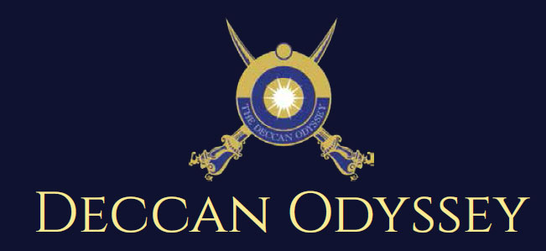

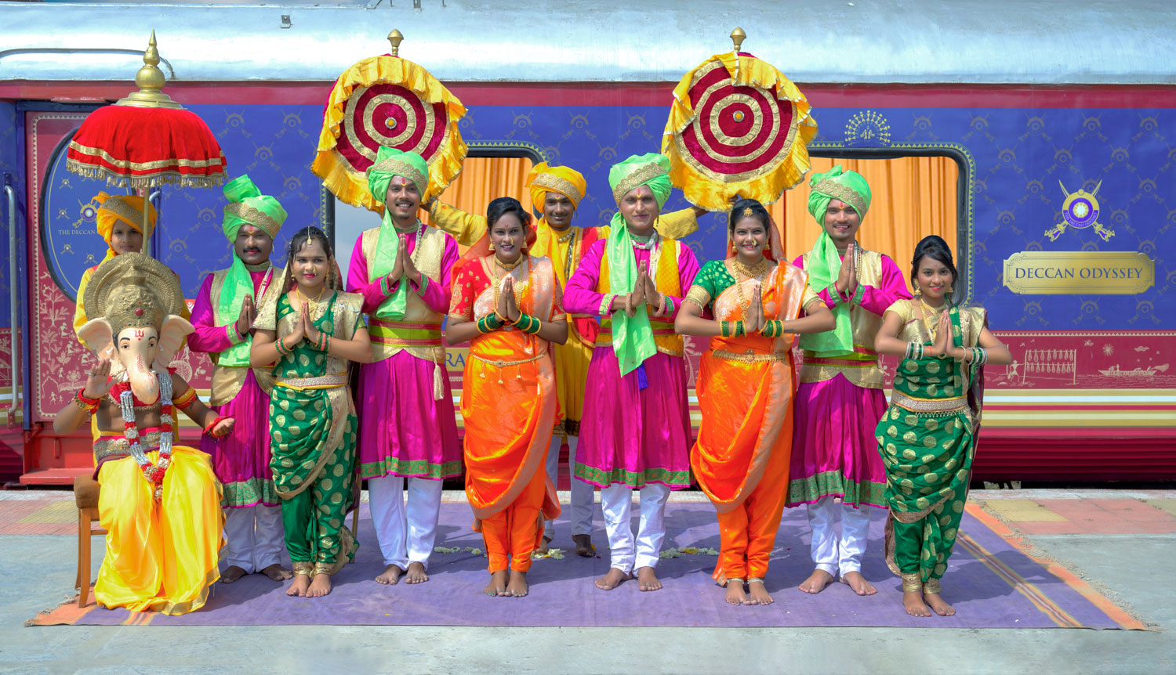

There's something unique about trains. They make you nostalgic. They transport us to far off places and we every day wake up to a new land of mystic and wonders. Trains are home to countless stories.

"Mickey Mouse popped out of my mind onto a drawing pad 20 years ago on a train ride from Manhattan to Hollywood at a time when business fortunes of my brother Roy and myself were at lowest ebb and disaster seemed right around the corner".

Walt Disney

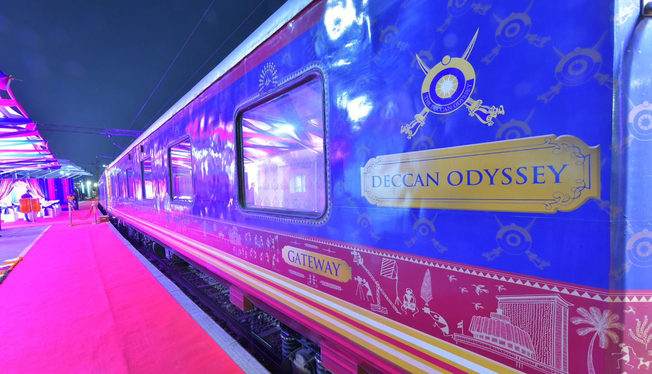

A journey that remains, magical and memorable. The Deccan Odyssey Train Routes and journeys designed to discover the art, architecture, culture, history and wildlife in style. Choose from set of excellent journeys that take you through different parts of India.

TRAIN LAYOUT
Passenger Cars (4 Coupes per Coach) (10)
Presidential Suite Cars (2 Coupes per Coach) (02)
Conference Car with Business Centre (01)
Restaurant Cars (02)
Staff, spare car (02)
Spa Car (01)
Bar Car (01)
Generator Cars with Luggage Store (02)
Total Coaches- 21 -
It can accommodate 88 guests at a time


PRESIDENTIAL SUITE

Dimensions  Cabin Area: 191 Sq Ft  Cabin Length: 8.4 meter  Cabin Width: 2.3 meter  Bed Length: 2.0 meter  Bed Width:0.9 meter  Cabin per Coach: 2 | Private attached bathroom with shower; channel music facility; Individual temperature control panel; direct dial telephone; electronic safe & small cupboard; Presidential suite cabins have a master bedroom with spacious living area, two bathrooms, Personal butler available in each sleeper carriage 24hrs.

DELUXE DOUBLE / TWIN CABINS
Dimensions  Cabin Area: 95 Sq Ft  Cabin Length: 3.97 meter  Cabin Width: 2.3 meter  Bed Length: 2.0 meter  Bed Width:0.9 meter  Cabin per Coach: 4 | Deluxe Coach features 4 Double/ Twin bed cabins. Direct dial phone, electronic safe, and individual climate control facility. Bathrooms come fitted with wash basin & shower, shower cubicle and running hot and cold water; Twin bed is 6' x 3'. Specially equipped cabin, for the comfort of our diﬀerently-abled guests.

RESTAURANTS

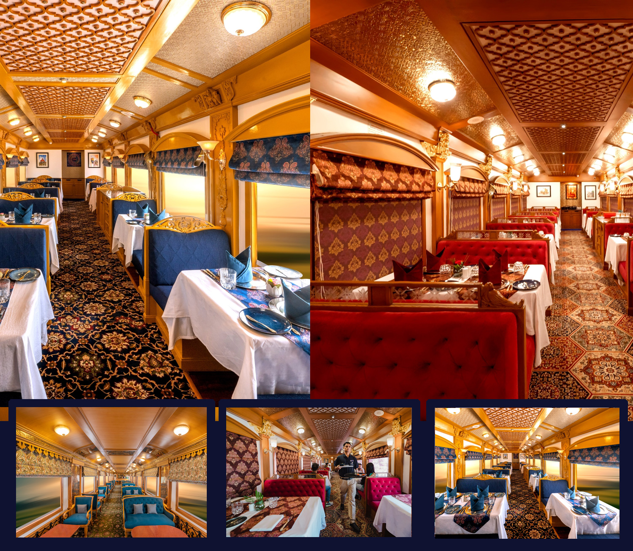
The Deccan Odyssey's two gourmet restaurants, Waavar and Utsav have been designed to keep the element of Indian royalty intact. Our chefs ensure the cuisine keeps pace with the train's journey, by creating local specialties of the every state that the train travels through. So you discover every location with all your senses, including your taste buds! Each meal also includes an International menu to choose from. To further enhance the gourmet experience, Deccan Odyssey presents travelers with a well-stocked bar - Gateway. This is the ideal spot to meet and know your fellow travelers, over an evening drink & snacks.

GATEWAY BAR
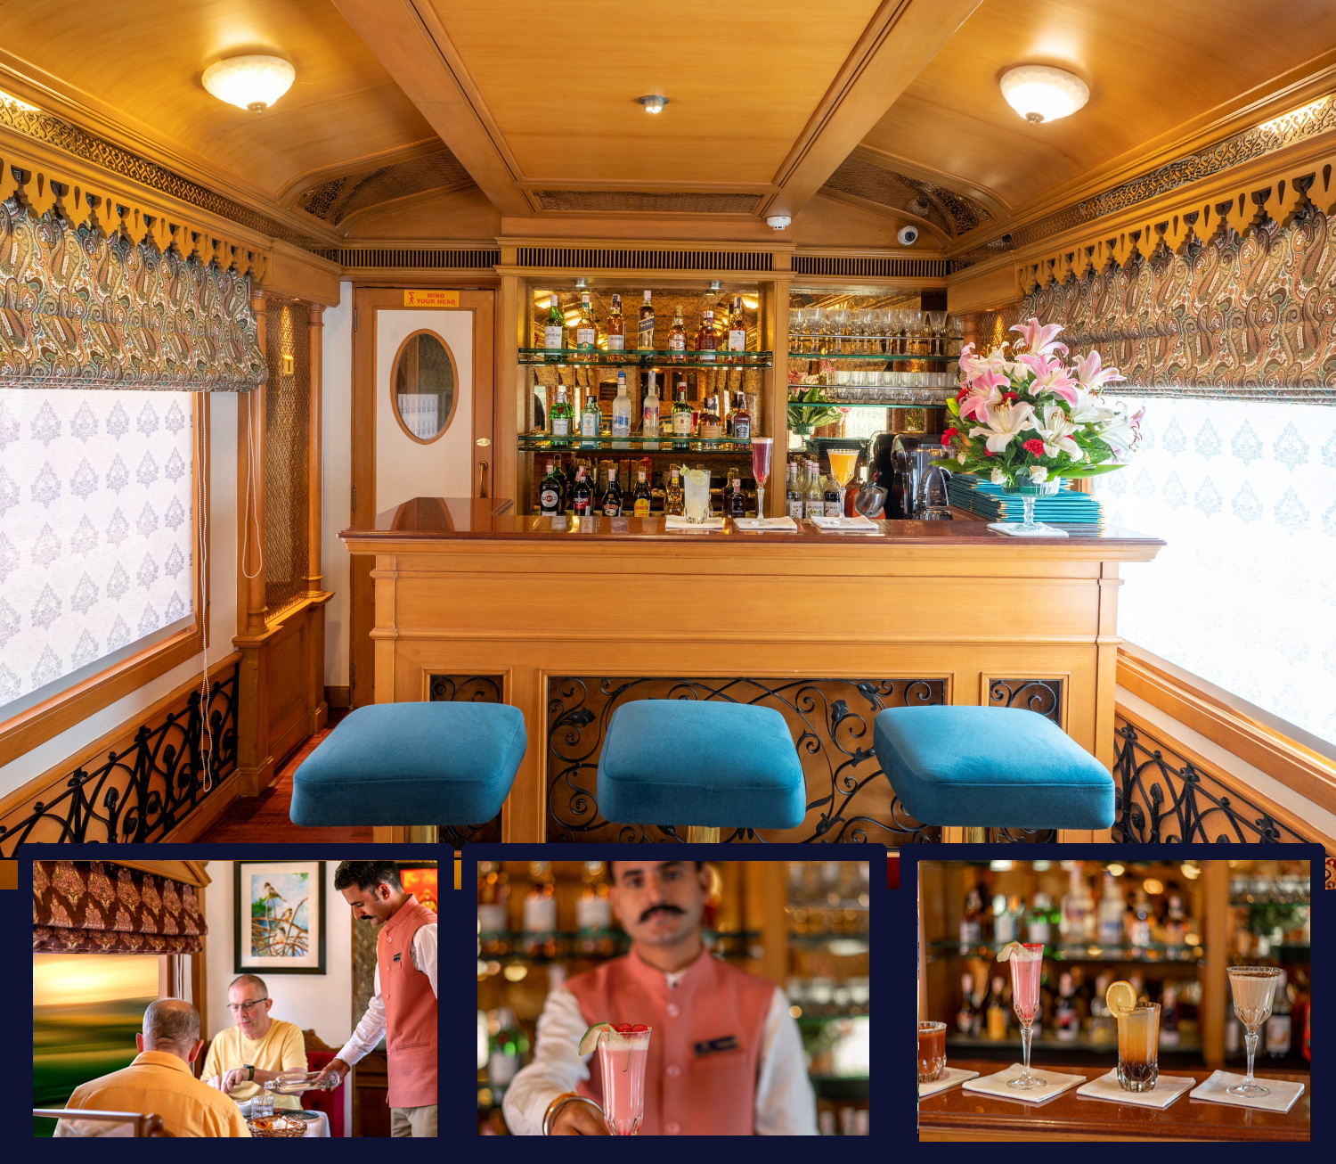
A Well-Stocked Bar with TV Facility serves Wine, Liquor and Spirits of Indian and International make.

CONFERENCE CAR
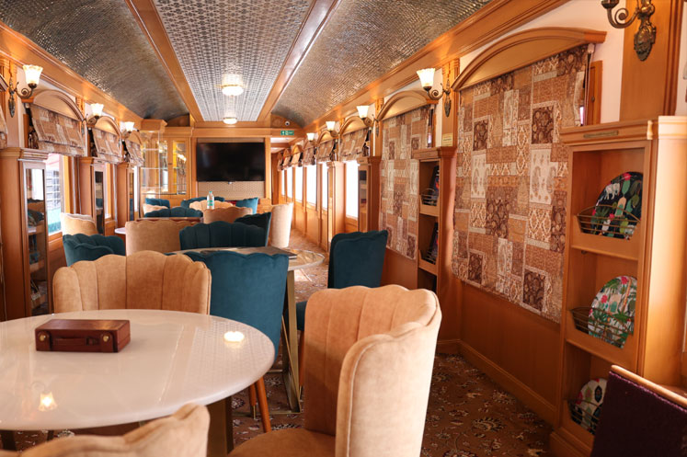
If work requires your time and attention, then our conference car, "Pankh" will take care of all your business needs. Equipped with the latest facilities, it ensures you manage your work efficiently even while you're away travelling.

SPA CAR

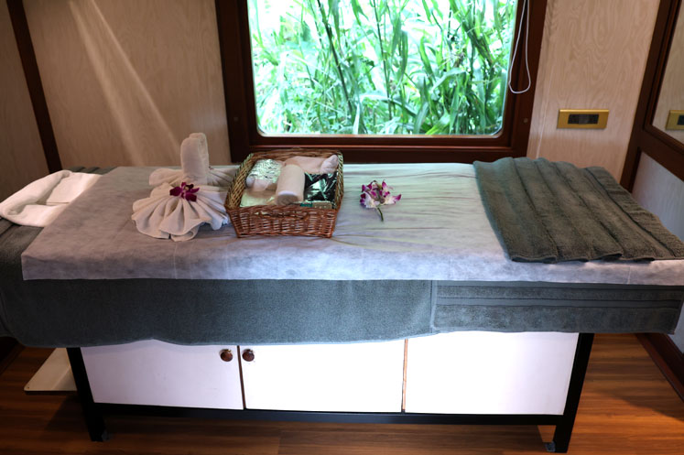

After a long day of exploration, head to Deccan Odyssey's wonderful spa "Ayush". The salon's well-trained masseurs, incorporate ancient Indian techniques to help you relax your body and rejuvenate your mind.

CULTURAL ODYSSEY ITINERARY

Duration:

Delhi | Sawai Madhopur | Jaipur | Agra | Varanasi | Khajuraho | Orchha | Delhi
07 Nights / 08 Days

CULTURAL ODYSSEY
Day 1 (Saturday): DELHI
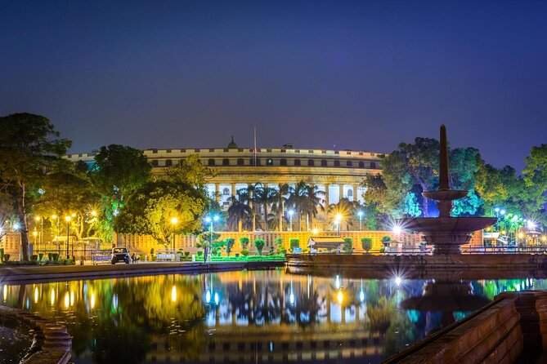
Board the Deccan Odyssey at Delhi – on to Sawai Ranthambore

Welcome aboard the Deccan Odyssey.

This evening assemble at the railway station at approximately 1715 hours to complete the registration process and check in formalities for your Indian Odyssey journey, as you receive a traditional Indian welcome and enjoy a refreshing welcome drink.

After completion of all formalities, you will be shown to your delightful cabins. As you settle in, the Deccan Odyssey shall depart Delhi for Sawai Madhopur.

1800 Hrs: Deccan Odyssey Departs for Sawai Madhopur
1930 Hrs: Dinner on Board

Overnight on Deccan Odyssey
Day 2 (Sunday): SAWAI MADHOPUR
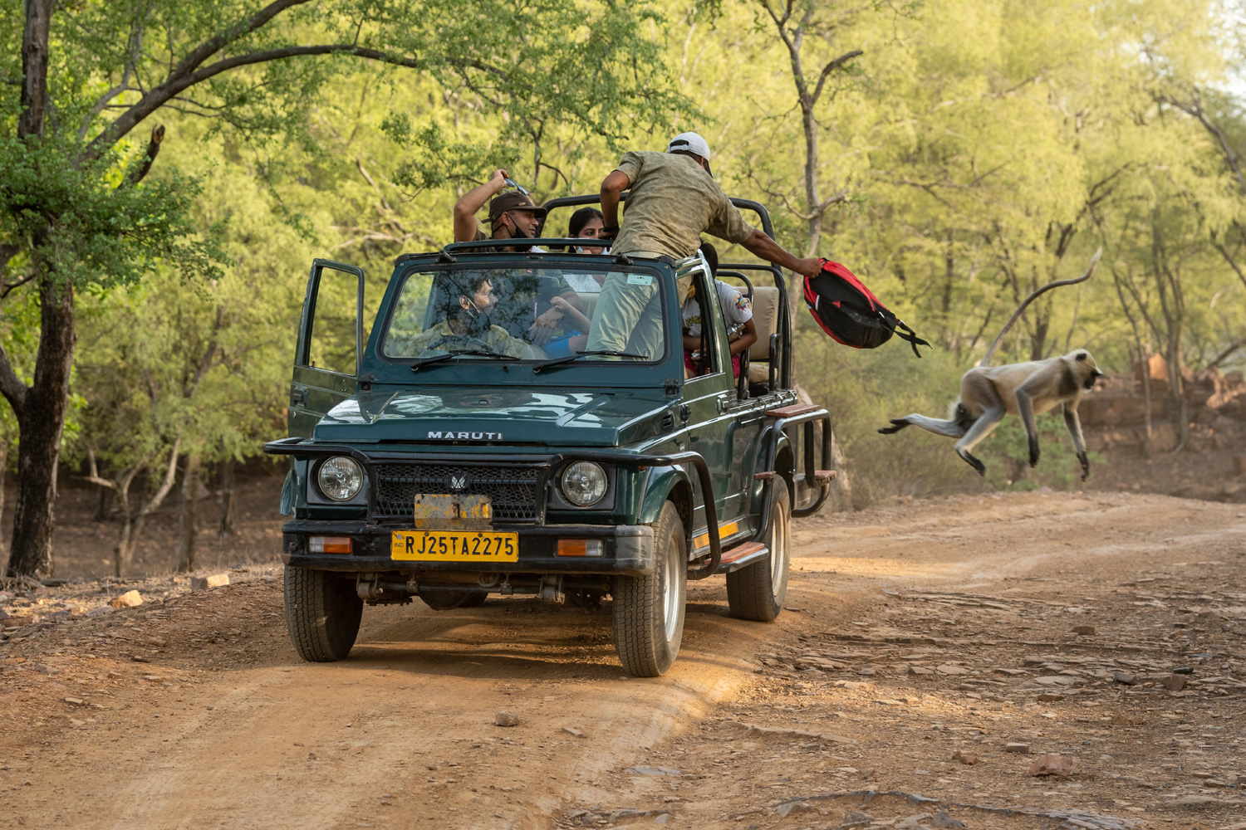
Sawai Madhopur, in Rajasthan is the alighting point for the famous Ranthambore National Park, and India’s efforts to conserve the dwindling tiger population can be seen here.

0700 Hrs: Breakfast on board the Deccan Odyssey
0830 Hrs: Day at leisure.
1230 Hrs: Return to Deccan Odyssey for Lunch
1430 Hrs: Disembark to head for the afternoon safari.
1715 Hrs: Head back to the Deccan Odyssey where you can relax with a drink before dinner on board, as the Deccan Odyssey sets off for Jaipur.

Breakfast, Lunch & Dinner on board;

Overnight on Deccan Odyssey

Day 3 (Monday): JAIPUR
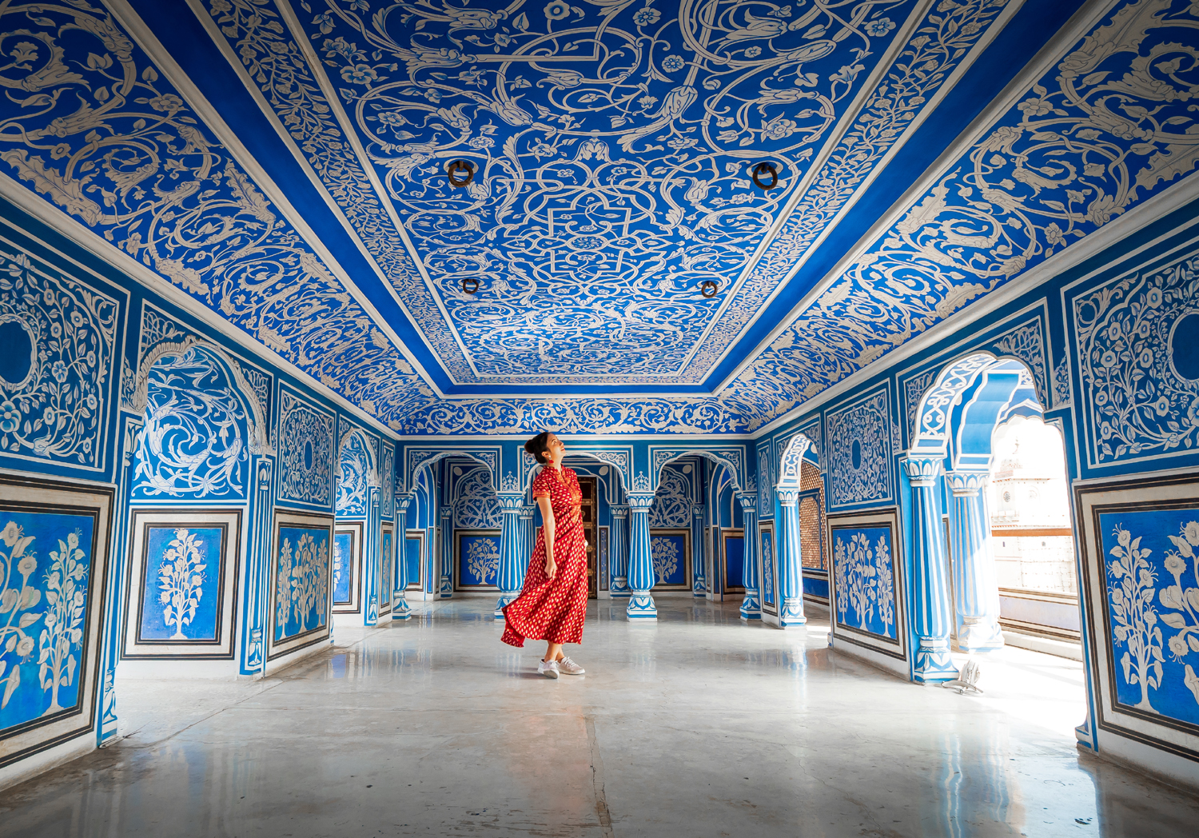

0700 Hrs: Breakfast on board the Deccan Odyssey
0830 Hrs: Disembark from Station ( Welcome at the station)
0900 Hrs: Leave station for Amber Fort
1030 Hrs: Visit of Amber Fort
1300 Hrs: Lunch at City Hotel
1530 Hrs: Visit of City Palace
1900 Hrs: Leave city Palace for Station

Breakfast on board, Lunch at a City hotel & Dinner on board

Overnight on Deccan Odyssey

Day 4 (Tuesday): AGRA
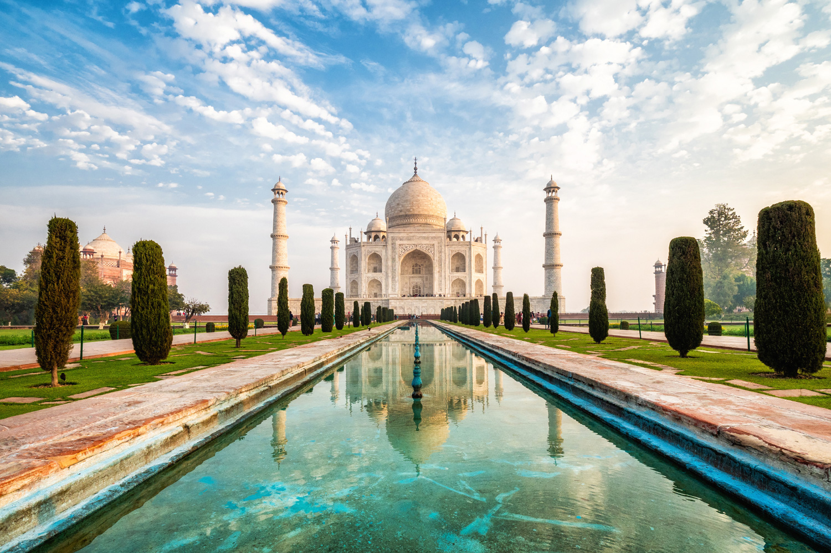
0700 Hrs: Breakfast on board the Deccan Odyssey
0830 Hrs: Deboard Deccan Odyssey and drive to Agra from Tundla Railway Station
0930 Hrs: You will visit the Taj Mahal, which was Emperor Shah Jahan’s gift of love to his beloved
wife, Mumtaz Mahal, and is truly the world’s most wondrous monument.
1300 Hrs: Lunch at City Hotel.
1400 Hrs: Proceed for Agra Fort another outstanding example of Mughal architecture.
1630 Hrs: Visit Kalakriti to witness the art of Inlay Work which can be found in Mughal structures.
The Technique is known as Pietra Dura which have beautified Taj Mahal.
1900 Hrs: Return to the Deccan Odyssey for dinner.
Breakfast on board, Lunch at a City Hotel & Dinner on board

Overnight on Deccan Odyssey

Day 5 (WEDNESDAY): VARANASI
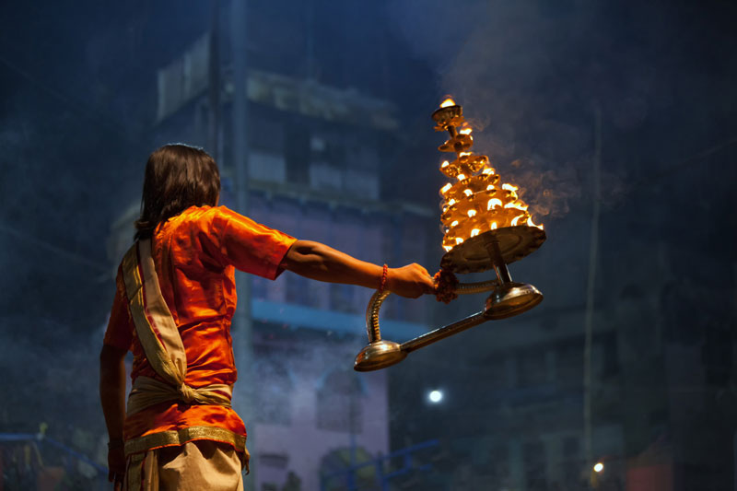
Arrive at Varanasi - The cradle of Mankind the oldest living city on this planet. Visit Temples & Ghat area, experience the lively bazaar and the mystic chaos. Enjoy a boat ride on the Holy Ganges.

0700 Hrs: Breakfast on board the Deccan Odyssey.
0900 Hrs: Deboard Deccan Odyssey and proceed for sightseeing tour of Sarnath
1300 Hrs: Lunch at City Hotel.
1500 Hrs: Proceed for evening boat ride and witness night aarti ceremony.
2000 Hrs: Return to Deccan Odyssey.

Breakfast on board, Lunch at a City Hotel & Dinner on board

Overnight on Deccan Odyssey

Day 6 (Thursday): KHAJURAHO
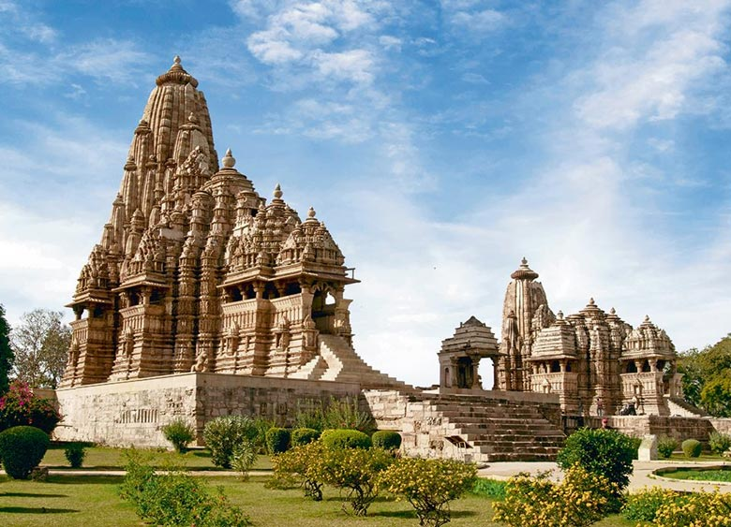
Arrive at the historic city of Khajuraho, which beholds the World Heritage Monument the Chandela Temple complex. Morning Sightseeing. Lunch onboard and leave for Orcha

0700 Hrs: Breakfast on board the Deccan Odyssey

0830 Hrs: Deboard Deccan Odyssey and proceed for sightseeing tour of Khajuraho visiting Western & Eastern group of temples.

1300 Hrs: Return to Deccan Odyssey and Lunch onboard

Breakfast, Lunch & Dinner on board

Overnight on Deccan Odyssey

Day 7 (FRIDAY): ORCHHA
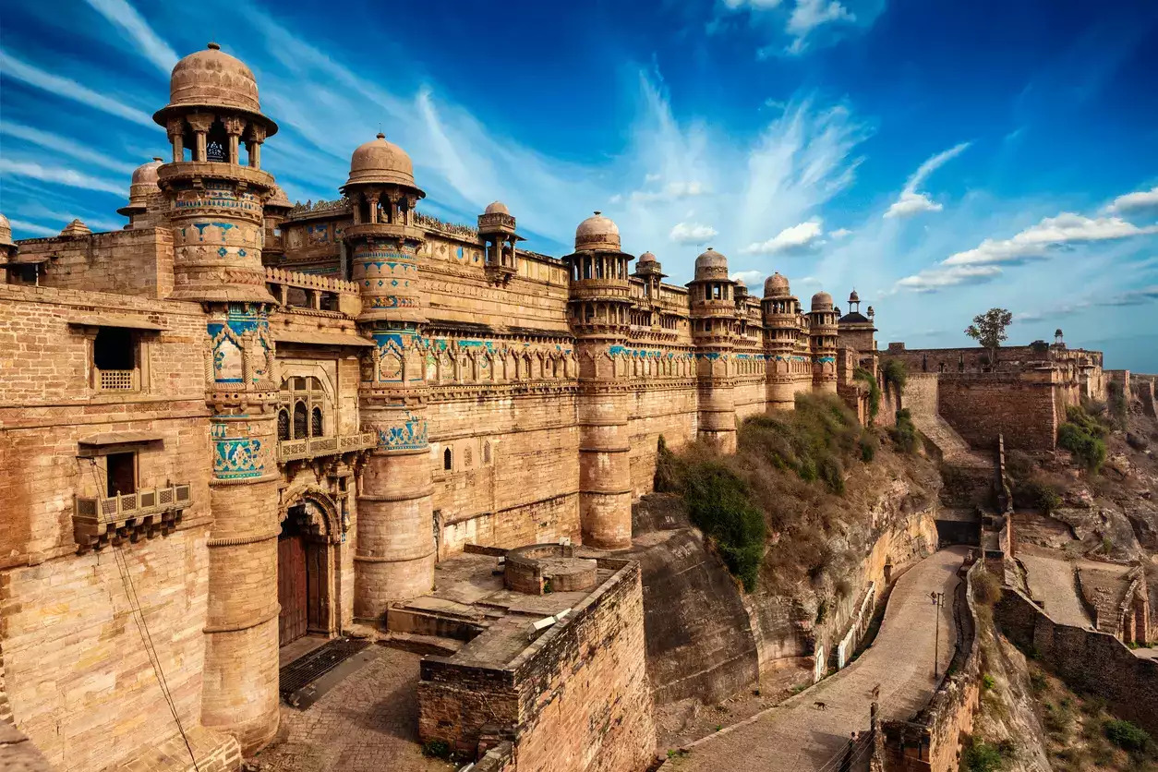
Today the Deccan Odyssey arrives at Orchha. Visit the fort, and experience village life as well.
(Optional Gwalior visit)

0700 Hrs: Breakfast on board the Deccan Odyssey.
0830 Hrs: Deboard Deccan Odyssey and proceed for sightseeing tour of Orcha.
1300Hrs: Lunch On Board.
1600 Hrs: Proceed for the Tuk Tuk ride and village tour of Orcha.
1800 Hrs: Return to Deccan Odyssey.

Breakfast on board, Lunch at a City Hotel & Dinner on board

Overnight on Deccan Odyssey

Day 8 (Saturday): DELHI
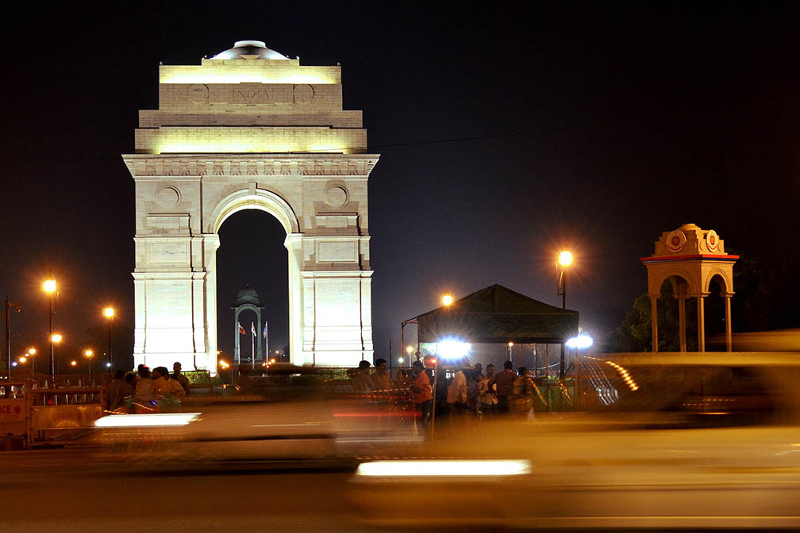
Disembark in Delhi

0800 Hrs: Disembark in Delhi

Early this morning, after breakfast, you will disembark at the Delhi Safdarjung Station.

Bid farewell to the Deccan Odyssey as your royal passage through the grand vistas of India comes to an end.

Breakfast on board

DEPARTURE DATES
2025 | 2026 | 2027
29 November  27 December | 07 March  11 April  28 November  26 December | 06 March  10 April

TARIFF 2025-2026 (Per Cabin Per Journey)
Category | Single Occupancy | Double Occupancy | 02 Children  (in a separate deluxe cabin)
Deluxe Cabin | $9,330 | $13,300 | Price on Request
Presidential Suite | $20,000 | $20,000 | Price on Request

TARIFF 2026-2027 (Per Cabin Per Journey)
Category | Single Occupancy | Double Occupancy | 02 Children  (in a separate deluxe cabin)
Deluxe Cabin | $9,330 | $13,300 | Price on Request
Presidential Suite | $20,000 | $20,000 | Price on Request

Inclusions | Exclusions
- Accommodation in double / twin bedded cabin with en suite bathrooms  - All meals (B, L, D)  - Soft beverages during the journey  - Valet service  - Still camera fees  - Guided oﬀ train excursions and game drives as illustrated in the itinerary – inclusive of entrance fees, park fees, transport and services of an English-speaking local guide | - Taxes including 5.00% (subject to change as per Govt. directives)  - Government Service tax, Insurance, gratuities  - Laundry and alcoholic Beverages  - Video and professional Still camera fees  - Arrival and Departure transfers  - International and Domestic air tickets  - Pre and Post tour accommodation and any tour extensions unless specifically mentioned as a part of the journey  - All activities mentioned as ‘options’ in the itinerary.
Booking Policy
20% of the tariff: at the time of the confirmation of the booking.
Remaining 80% of the tariff: to be paid 60 days prior to departure
Cancellation Policy
Retention of 10% of ticket value: cancelling 60 days prior to the departure date.
Retention of 20% of ticket value: cancelling 59 – 45 days prior to the departure date
Retention of 50% of ticket value: cancelling 44 – 30 days prior to the departure date
Retention of 100% of ticket value: cancelling 29 – 45 days prior to the departure date
Terms and Conditions
- All Costs are in USD
- The above costs are per cabin per Journey
- As the train runs on the tracks of the Indian Railways, the itineraries are subject to change in case of any changes in the routing
- Prices are subject to change in case of any amendment in the routing or other hikes such as fuel, taxes
- Children below 5 years of age shall be allowed free, subject to sharing of double bed with This is subject to availability of double bed at the time of booking
- Presidential Suite can accommodate up to 3 adults or 2 Adults and 2 children (One child up to 5 years of age and second child up to 12 years of age)
- Government Service tax of 5.00% (subject to change as per Govt. directives) is additional and will be charged extra on the published tariﬀ.
- All Departures and Arrivals are on Tentative basis and are subject to approval from Indian Railways.
- The Entire Deccan Odyssey Train is non Smoking. For any particular requirement, kindly contact your Valet.
- We need minimum occupancy to operate all listed journeys, in event if we do not manage minimum occupancy we reserve the right to cancel the journey at least with 30 days prior intimation.
- As Train runs on tracks so you may experience sounds of passing trains and some shaking during the journey. This is a normal feature countrywide with trains in India.
- Paramedic on Board
